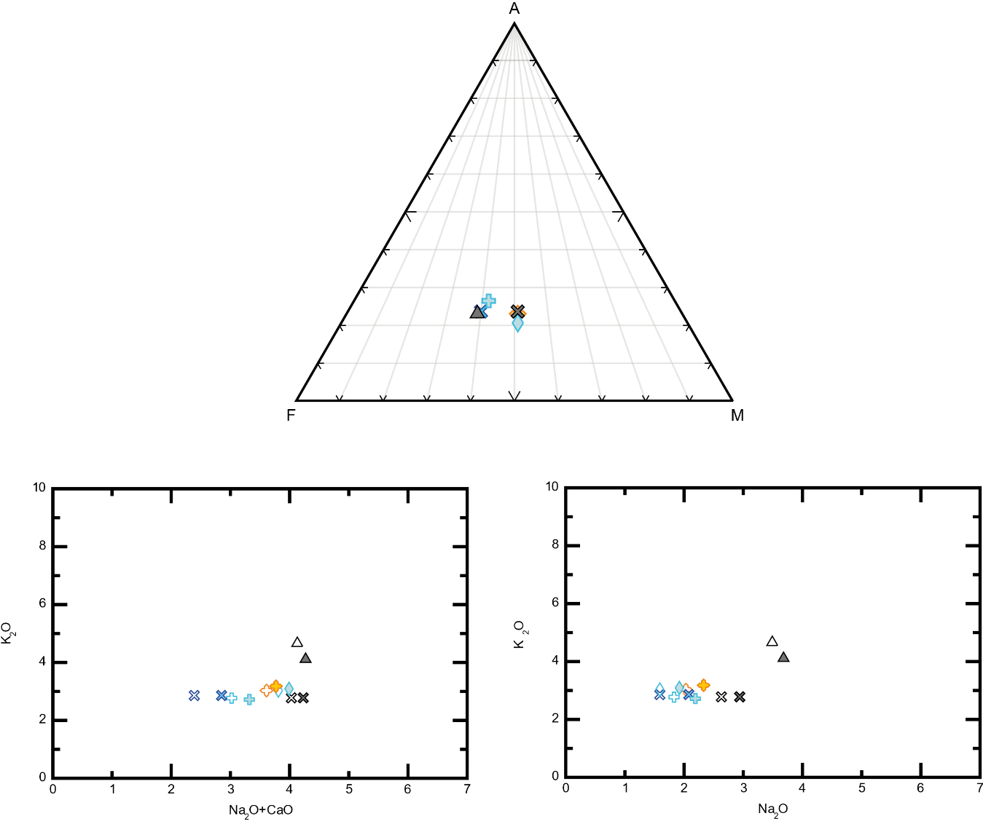
ADDITIONAL DIAGRAMS NOT USED IN THE THESIS
a

c
b

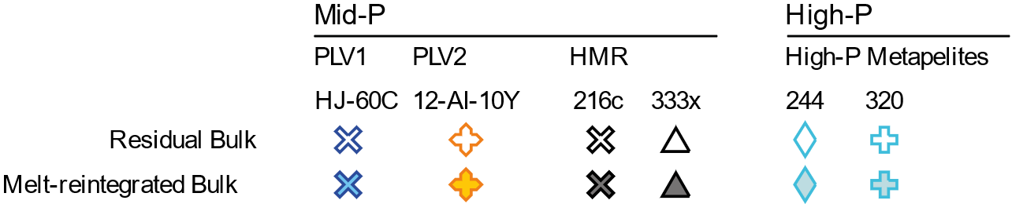
Appendix D1: Melt-reintegrated bulk compositions of the PLV metapelites, hydrothermally modified rocks (HMR) and high-P metapelites. a) AFM diagram. b) Binary $K_{2}O$ vs ${Na}_{2}O$ diagram. c) Binary $K_{2}O$ vs ${Na}_{2}O$ $+ CaO$ diagram.

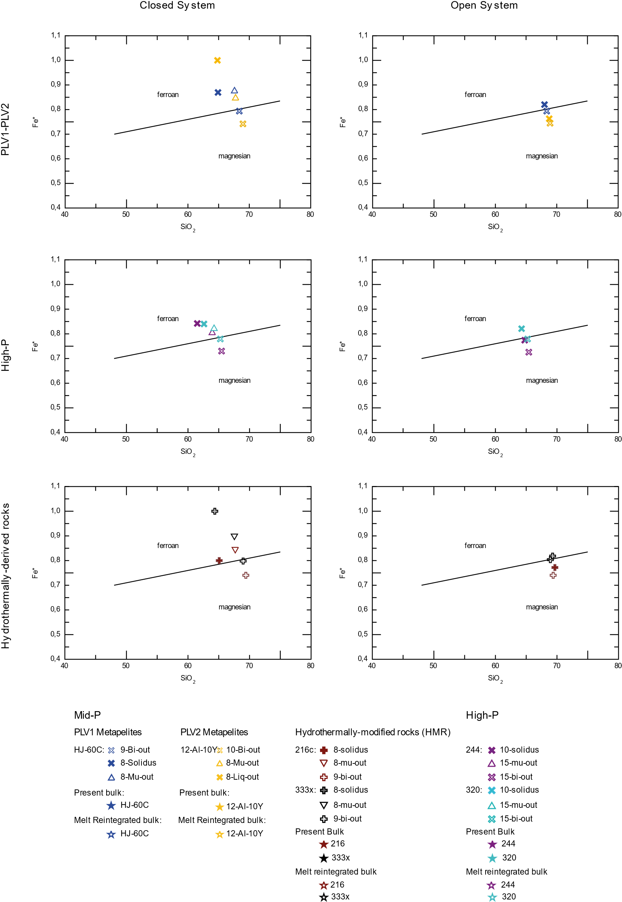
Appendix D2: ${SiO}_{2}$vs Fe* diagram (wt%) of the calculated melts.

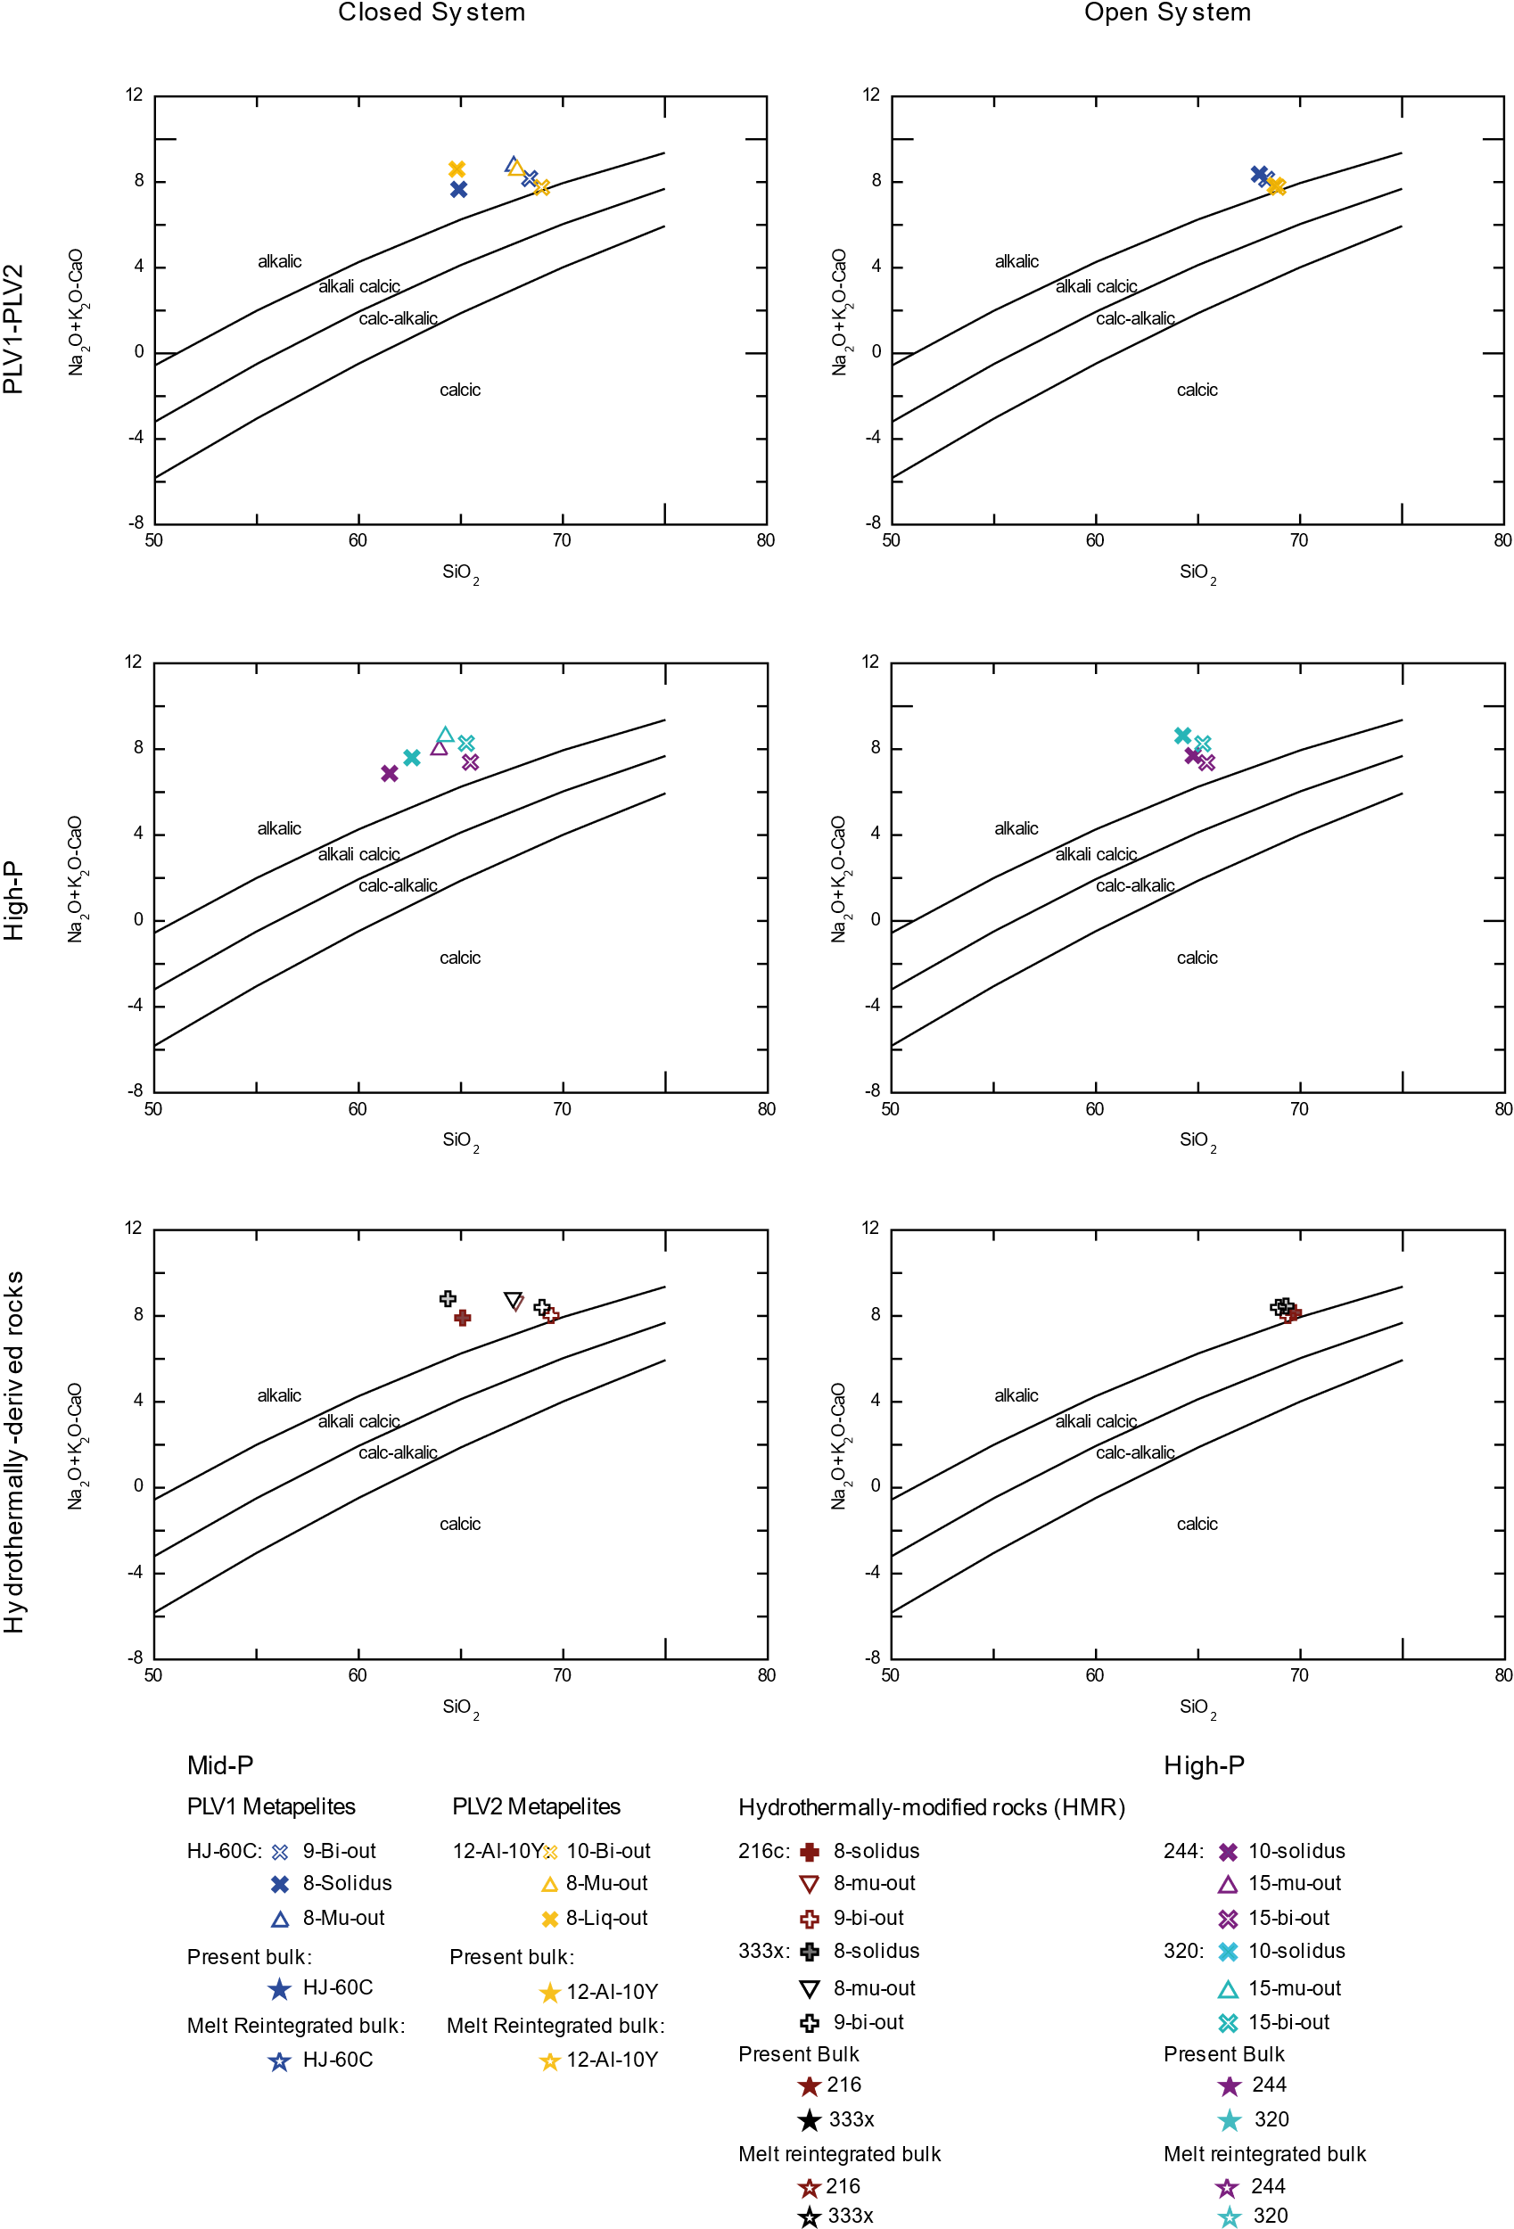
Appendix D3: ${SiO}_{2}$vs MALI diagram (wt%) of the calculated melts.

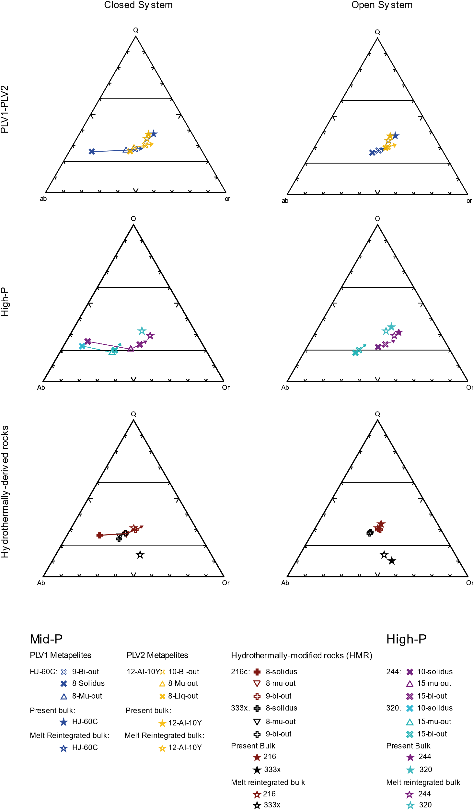
Appendix D4: Normative Q-Ab-Or diagrams (wt%) of the calculated melts.

