Petrography PLV2 Metapelites
Table of Contents
- 12-AI-10a 2
- 12-AI-10e 3
- 12-AI-10e1 4
- 12-AI-10e2 5
- 12-AI-10y 6
- 12-AI-10z 7
- 12-AI-10f 8
- 12-AI-46b 9
- 12-AI-49 10
- 12-AI-49b 11

1. 12-AI-10a:
Variably disrupted network of garnet, biotite, and sillimanite elongated along the foliation, separated by quartzofeldspathic pods.
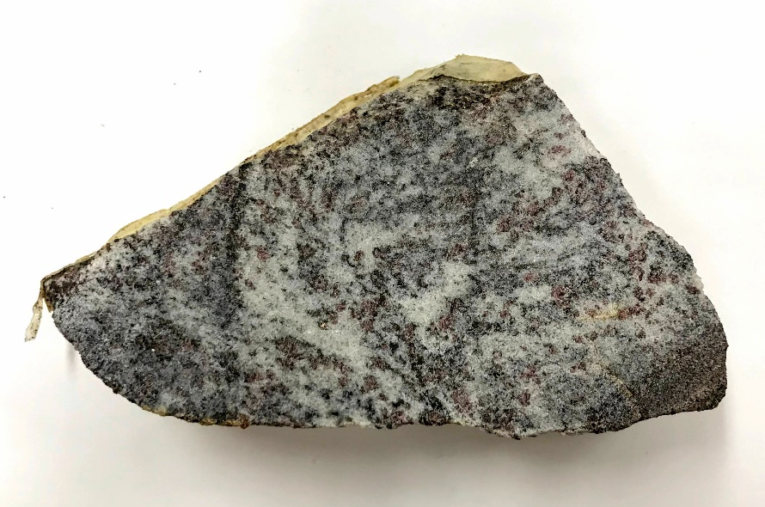
Main assemblage: Garnet, sillimanite, biotite, K-feldspar, plagioclase, and quartz.
Assemblage in the quartzofeldspathic pods: K-feldspar, plagioclase, quartz, and biotite.
Minor phases: Opaques, monazite, and zircon.
Microstructures:
Garnet is present as porphyroblasts, they are sub-rounded to elongated along the foliation. There are some smaller subhedral to euhedral grains. Usually, it contains inclusions of sillimanite, biotite, quartz, or feldspar in a pool of felsic composition and polymineralic inclusions of quartz, feldspar, and biotite within a felsic pool. Some of the garnet rims are replaced by biotite and sillimanite clusters.
Sillimanite is present as prismatic crystals forming clusters along the foliation, frequently with biotite in garnet replacement sites. It also occurs as fibrous inclusions in garnet.
Biotite forms large single laths or clusters, commonly with sillimanite, surrounding garnet and as smaller interstitial flakes in the quartzofeldspathic pods.
Quartz and feldspar show a relatively heterogeneous distribution with uniform grain size. K-feldspar shows perthitic texture. In addition, quartz, and feldspar form embayments in resorbed garnet and define finer microstructures including felsic pools and interstitial films. The felsic pools are found inside garnet and surrounding sillimanite. The interstitial films are preferentially in garnet grain boundaries with resorbed quartz.

2. 12-AI-10e:
Variably disrupted network of garnet, biotite, and sillimanite elongated along the foliation, separated by quartzofeldspathic pods.

Main assemblage: Garnet, sillimanite, biotite, K-feldspar, plagioclase, and quartz.
Assemblage in the quartzofeldspathic pods: K-feldspar, plagioclase, quartz, biotite and garnet.
Minor phases: Rutile, opaques, monazite and zircon.
Microstructures:
Garnet is present as porphyroblasts, they are sub-rounded to elongated along the foliation. There are some smaller subhedral to euhedral grains. Usually, it contains inclusions of sillimanite, biotite, quartz, or feldspar in a pool of felsic composition and polymineralic inclusions of quartz, feldspar, and biotite within a felsic pool. Some of the garnet rims are replaced by biotite and sillimanite clusters.
Sillimanite is present as prismatic crystals forming clusters along the foliation, frequently with biotite in garnet replacement sites. It also occurs as fibrous inclusions in garnet.
Biotite forms large single laths or clusters, commonly with sillimanite, surrounding garnet and as smaller interstitial flakes in the quartzofeldspathic pods.
Quartz and feldspar show a relatively heterogeneous distribution with uniform grain size. K-feldspar shows perthitic texture. In addition, quartz, and feldspar form embayments in resorbed garnet and define finer microstructures including felsic pools and interstitial films. The felsic pools are found inside garnet and surrounding sillimanite. The interstitial films are preferentially in garnet grain boundaries with resorbed quartz
3. 12-AI-10e1:
Variably disrupted network of biotite and sillimanite elongated along the foliation, separated by quartzofeldspathic pods and leucocratic domains composed mainly of k-feldspar.
Main assemblage: Garnet, sillimanite, biotite, K-feldspar, plagioclase, and quartz.
Assemblage in the quartzofeldspathic pods: K-feldspar, plagioclase, quartz, and biotite.
Minor phases: Muscovite, opaques, monazite and zircon.
Microstructures:
Garnet is present as porphyroblasts, they are sub-rounded to elongated along the foliation. There are some smaller subhedral to euhedral grains. Usually, it contains inclusions of sillimanite, biotite, quartz, or feldspar in a pool of felsic composition and polymineralic inclusions of quartz, feldspar, and biotite within a felsic pool. Some of the garnet rims are replaced by biotite and sillimanite clusters.
Sillimanite only occurs as fibrous inclusions in garnet.
Biotite forms large single laths or clusters, commonly with sillimanite, surrounding garnet and as smaller interstitial flakes in the quartzofeldspathic pods. Some biotite is being replaced by chlorite.
Quartz and feldspar show a relatively heterogeneous distribution with uniform grain size. K-feldspar shows perthitic texture. In addition, quartz, and feldspar form embayments in resorbed garnet and define finer microstructures including felsic pools and interstitial films. The felsic pools are found inside garnet and surrounding sillimanite. The interstitial films are preferentially in garnet grain boundaries with resorbed quartz

4. 12-AI-10e2:
Darker domains composed of biotite and garnet disrupted by quartzofeldspathic layers.
Main assemblage: Garnet, biotite, K-feldspar, plagioclase, and quartz.
Assemblage in the quartzofeldspathic pods: K-feldspar, plagioclase, quartz, and biotite.
Minor phases: Oxides, opaques, apatite, monazite and zircon.
Microstructures:
Garnet is present as porphyroblasts, they are sub-rounded to elongated along the foliation. There are some smaller subhedral to euhedral grains. Usually, it contains inclusions of biotite, quartz, or feldspar in a pool of felsic composition and polymineralic inclusions of quartz, feldspar, and biotite within a felsic pool.
Biotite forms large single laths or clusters and as smaller interstitial flakes in the quartzofeldspathic pods.
Quartz and feldspar show a relatively heterogeneous distribution with uniform grain size. K-feldspar shows perthitic texture. In addition, quartz, and feldspar form embayments in resorbed garnet and define finer microstructures including felsic pools and interstitial films. The felsic pools are found inside garnet. The interstitial films are preferentially in garnet grain boundaries with resorbed quartz

5. 12-AI-10y:
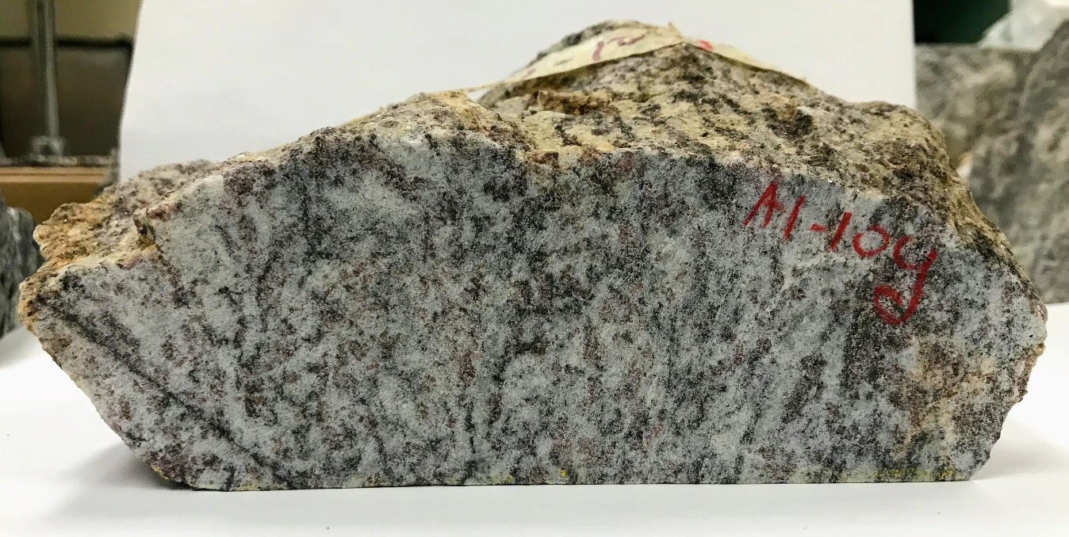
Variably disrupted network of biotite and sillimanite elongated along the foliation, separated by quartzofeldspathic pods

Main assemblage: Garnet, sillimanite, biotite, K-feldspar, plagioclase, and quartz.
Assemblage in the quartzofeldspathic pods: K-feldspar, plagioclase, quartz, and biotite.
Minor phases: Oxides, opaques, monazite and zircon.
Microstructures:
Garnet is present as porphyroblasts, they are sub-rounded to elongated along the foliation. There are some smaller subhedral to euhedral grains. Usually, it contains inclusions of sillimanite, biotite, quartz, or feldspar in a pool of felsic composition and polymineralic inclusions of quartz, feldspar, and biotite within a felsic pool. Some of the garnet rims are replaced by biotite and sillimanite clusters.
Sillimanite is present as prismatic crystals forming clusters along the foliation, frequently with biotite in garnet replacement sites. It also occurs as fibrous inclusions in garnet.
Biotite forms large single laths or clusters, commonly with sillimanite, surrounding garnet and as smaller interstitial flakes in the quartzofeldspathic pods.
Quartz and feldspar show a relatively heterogeneous distribution with uniform grain size. K-feldspar shows perthitic texture. In addition, quartz, and feldspar form embayments in resorbed garnet and define finer microstructures including felsic pools and interstitial films. The felsic pools are found inside garnet and surrounding sillimanite. The interstitial films are preferentially in garnet grain boundaries with resorbed quartz.
6. 12-AI-10z:
Alternation of darker layers composed of biotite, sillimanite and garnet with quartzofeldspathic layers, disrupted by quartzofeldspathic domains. Sillimanite is only present as inclusions in garnet.
Main assemblage: Garnet, sillimanite, biotite, K-feldspar, plagioclase, and quartz.
Assemblage in the quartzofeldspathic pods: K-feldspar, plagioclase, quartz, biotite and garnet.
Minor phases: Oxides, opaques, carbonates, monazite and zircon.

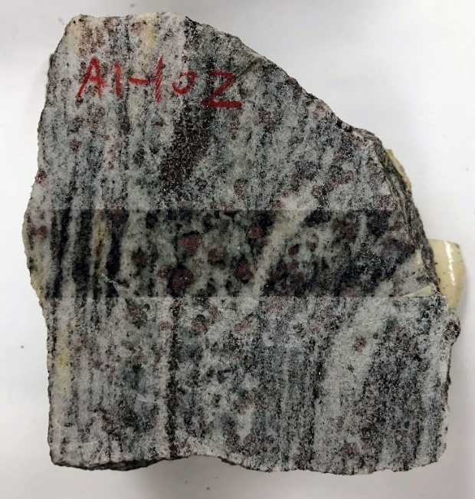

Microstructures:
Garnet is present as porphyroblasts, they are sub-rounded to elongated along the foliation. There are some smaller subhedral to euhedral grains. Usually, it contains inclusions of biotite, quartz, or feldspar in a pool of felsic composition and polymineralic inclusions of quartz, feldspar, and biotite within a felsic pool. Some of the garnet rims are replaced by biotite.
Sillimanite is only present as fibrous inclusions in garnet.
Biotite forms large single laths or clusters, commonly surrounding garnet and as smaller interstitial flakes in the quartzofeldspathic pods.
Quartz and feldspar show a relatively heterogeneous distribution with uniform grain size. K-feldspar shows perthitic texture. In addition, quartz, and feldspar form embayments in resorbed garnet and define finer microstructures including felsic pools and interstitial films. The felsic pools are found inside garnet. The interstitial films are preferentially in garnet grain boundaries with resorbed quartz.
7. 12-AI-10f:
Garnet porphyroblasts in a plagioclase, k-feldspar and quartz groundmass. The bottom part of the sample is finer grain and contains more garnet and biotite that the top part. Presence of veins with carbonates.
Main assemblage: Garnet, sillimanite, biotite, K-feldspar, plagioclase, and quartz.
Assemblage in the quartzofeldspathic pods: K-feldspar, plagioclase, quartz, biotite and garnet.
Minor phases: Oxides, opaques, carbonates, monazite and zircon.
Microstructures:
Garnet is present as porphyroblasts, they are sub-rounded to elongated along the foliation. There are some smaller subhedral to euhedral grains. Usually, it contains inclusions of biotite, quartz, or feldspar in a pool of felsic composition and polymineralic inclusions of quartz, feldspar, and biotite within a felsic pool. Some of the garnet rims are replaced by biotite.
Sillimanite is only present as fibrous inclusions in garnet.
Biotite forms large single laths or clusters, commonly surrounding garnet and as smaller interstitial flakes in the quartzofeldspathic pods.
Quartz and feldspar show a relatively heterogeneous distribution with different grain size. K-feldspar shows perthitic texture. In addition, quartz, and feldspar form embayments in resorbed garnet and define finer microstructures including felsic pools and interstitial films. The felsic pools are found inside garnet. The interstitial films are preferentially in garnet grain boundaries with resorbed quartz.

8. 12-AI-46b:
Alternation of darker layers composed of biotite, sillimanite, and garnet with quartzofeldspathic layers, disrupted by quartzofeldspathic domains.
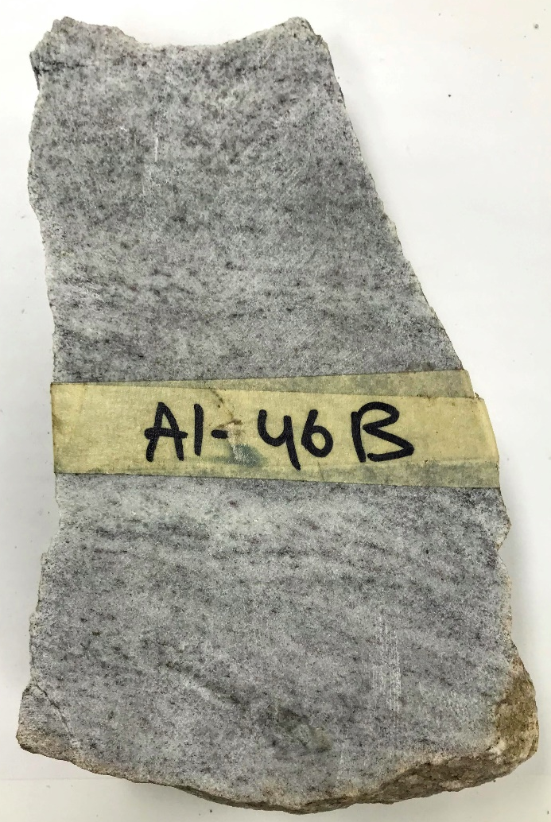
Main assemblage: Garnet, sillimanite, biotite, K-feldspar, plagioclase, and quartz.
Assemblage in the quartzofeldspathic pods: K-feldspar, plagioclase, quartz, biotite and garnet.
Minor phases: Oxides, opaques, monazite and zircon.
Microstructures:
Garnet is present as porphyroblasts, they are sub-rounded to elongated along the foliation, and as smaller anhedral to subhedral grains. Usually, it contains inclusions of sillimanite, biotite, quartz, or feldspar.
Sillimanite is present as prismatic crystals forming clusters along the foliation, frequently with biotite in garnet replacement sites. It also occurs as fibrous inclusions in garnet.
Biotite forms large single laths or clusters, commonly with sillimanite, surrounding garnet and as smaller interstitial flakes in the quartzofeldspathic pods. Some biotite is being replaced by chlorite.
Quartz and feldspar show a relatively homogeneous distribution and grain size, being quartz the most dominant mineral in the sample (70%). Feldspar is partially altered.

9. 12-AI-49:
Alternation of darker layers composed of biotite, sillimanite, and garnet with disrupted by feldspathic domains. There are some more prominent k-feldspar rich layers, with perthitic texture.
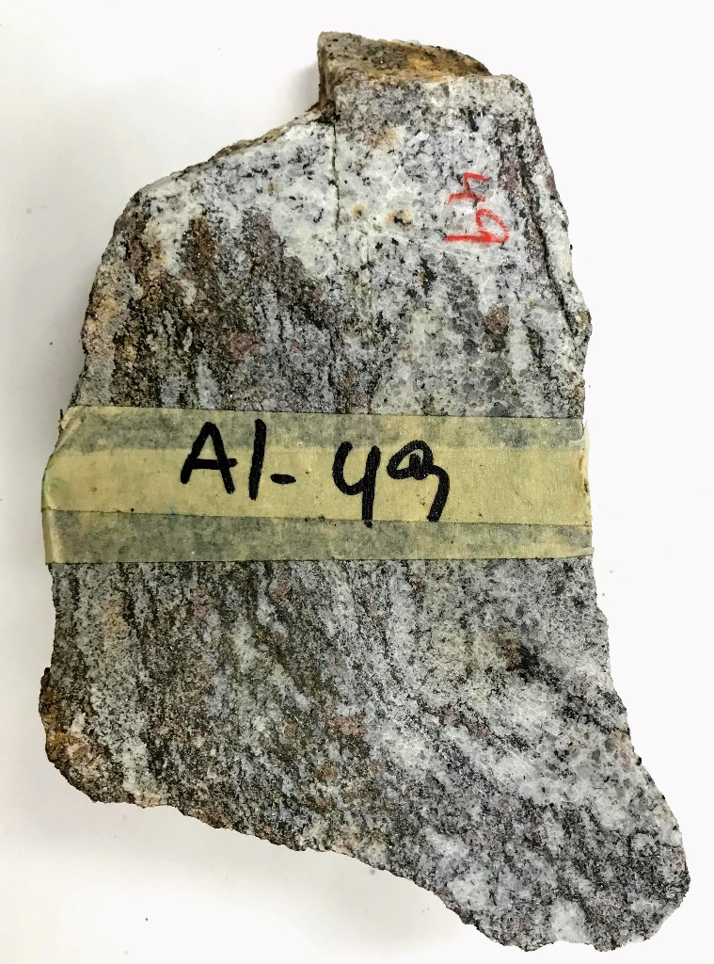
Main assemblage: Garnet, sillimanite, biotite, K-feldspar, plagioclase.
Feldspathic assemblage: K-feldspar, plagioclase, biotite and very little quartz.
Minor phases: Oxides, opaques, monazite and zircon.
Microstructures:
Garnet is present as porphyroblasts, they are sub-rounded to elongated along the foliation, and as smaller anhedral to subhedral grains. Usually, it contains inclusions of sillimanite, biotite, quartz, or feldspar in a pool of felsic composition and polymineralic inclusions of quartz, feldspar, and biotite within a felsic pool. Some of the garnet rims are replaced by biotite and sillimanite clusters.
Biotite is present as clusters around garnet, as inclusions in garnet, forming layers with sillimanite, and in the groundmass as interstitial individual flakes. It appears to be associated with graphite.
Sillimanite is associated with biotite forming aluminous layers, it also occurs as clusters around garnet, it is also present as inclusions in garnet.
Feldspars show a relatively homogeneous distribution and grain size. K-feldspar shows perthitic texture. K-feldspar and plagioclase form intergrowth textures.

10. 12-AI-49b:
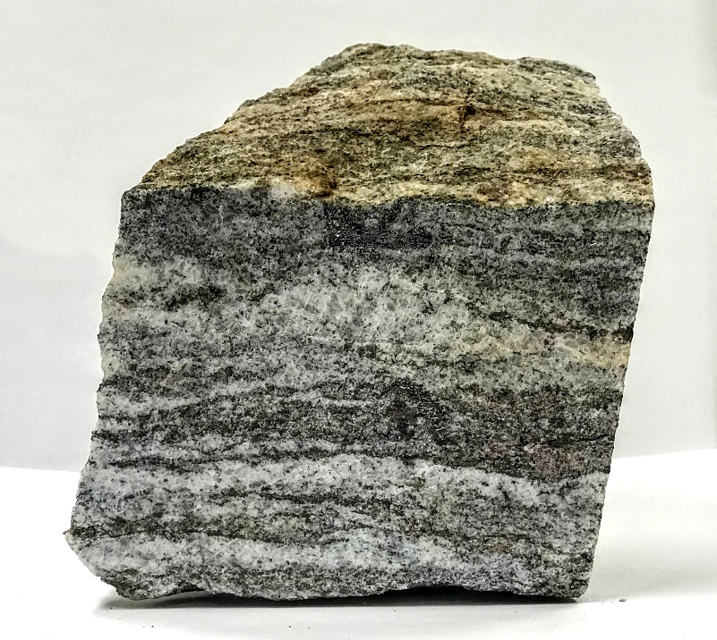
Alternation of darker layers composed of biotite, sillimanite, and garnet with disrupted by feldspathic domains. There are some more prominent k-feldspar rich layers, with perthitic texture.
Main assemblage: Garnet, sillimanite, biotite, K-feldspar, plagioclase.
Feldspathic assemblage: K-feldspar, plagioclase, biotite and very little quartz.
Minor phases: Oxides, opaques, monazite and zircon.
Microstructures:
Garnet is present as porphyroblasts, they are sub-rounded to elongated along the foliation, and as smaller anhedral to subhedral grains. Usually, it contains inclusions of sillimanite, biotite, quartz, or feldspar in a pool of felsic composition and polymineralic inclusions of quartz, feldspar, and biotite within a felsic pool. Some of the garnet rims are replaced by biotite and sillimanite clusters.
Biotite is present as clusters around garnet, as inclusions in garnet, forming layers with sillimanite, and in the groundmass as interstitial individual flakes. It appears to be associated with graphite.
Sillimanite is associated with biotite forming aluminous layers, it also occurs as clusters around garnet, it is also present as inclusions in garnet.
Feldspars show a relatively homogeneous distribution and grain size. K-feldspar shows perthitic texture. K-feldspar and plagioclase form intergrowth textures.

