Petrography PLV1 Metapelites
Table of Contents
- HJ-60b 2
- HJ-60c 2
- HJ-60d 3
- HJ-60d1 4
- HJ-60e 5
- HJ-60f 6
- HJ-60h 7
- HJ-80 8
- HJ-85 9
- HJ-88 10
- HJ-88d1 11
- HJ-88d2 12
- 08-60-1 13
- 08-60-2 14
- 08-60-3 15
- 08-60a-1 16
- 08-60a-2 17
- 08-60a-3 18
- 08-65-A 19
- 08-65-A1 20
- 08-66 21
- 08-67-1 22
- 08-67-2 23
- 08-67-3 24

1. HJ-60b: Studied by Lasalle, 2014 and Kendrick, 2017.
2. HJ-60c:
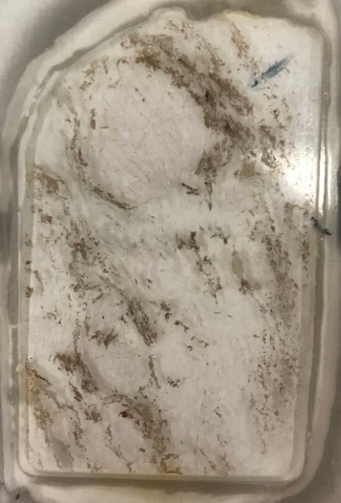
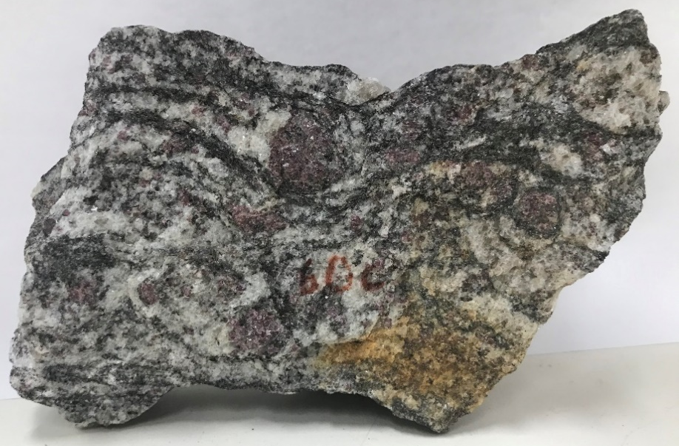
Variably disrupted network of garnet, biotite, and sillimanite elongated along the foliation, separated by quartzofeldspathic pods.

Main assemblage: Garnet, sillimanite, biotite, K-feldspar, plagioclase, and quartz.
Assemblage in the quartzofeldspathic pods: K-feldspar, plagioclase, quartz, biotite, and garnet.
Minor phases: Kyanite, rutile, oxides, opaques, monazite, and zircon.
Microstructures:
Garnet is present as porphyroblasts, they are sub-rounded to elongated along the foliation. There are some smaller subhedral to euhedral grains. Usually, it contains inclusions of sillimanite, biotite, quartz, or feldspar in a pool of felsic composition and polymineralic inclusions of quartz, feldspar, and biotite within a felsic pool. Some of the garnet rims are replaced by biotite and sillimanite clusters.
Sillimanite is present as prismatic crystals forming clusters along the foliation, frequently with biotite in garnet replacement sites. It also occurs as fibrous inclusions in garnet and pseudomorphing kyanite.
Kyanite occurs as a minor phase. It is present as resorbed crystals or being pseudomorphed by sillimanite.
Biotite forms large single laths or clusters, commonly with sillimanite, surrounding garnet and as smaller interstitial flakes in the quartzofeldspathic pods. Some biotite is being replaced by chlorite.
Quartz and feldspar show a relatively heterogeneous distribution with uniform grain size. K-feldspar shows perthitic texture. In addition, quartz, and feldspar form embayments in resorbed garnet and define finer microstructures including felsic pools and interstitial films. The felsic pools are found inside garnet and surrounding sillimanite. The interstitial films are preferentially in garnet grain boundaries with resorbed quartz.
HJ60d and HJ-60d1 series:
3. HJ60d:
Variably disrupted network of garnet, biotite, and sillimanite elongated along the foliation, separated by quartzofeldspathic pods.
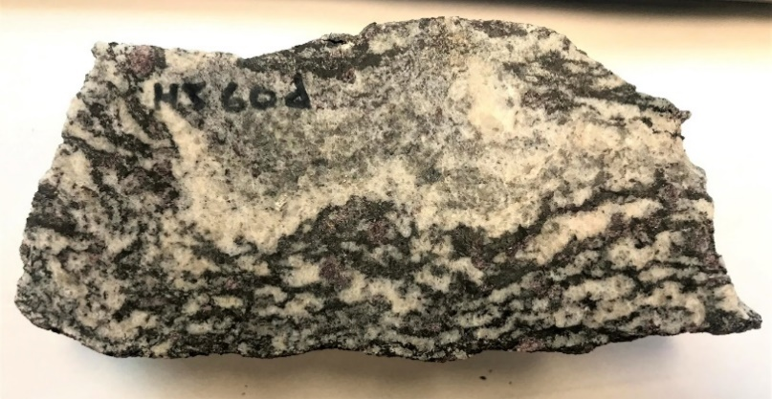
Main assemblage: Garnet, sillimanite, biotite, K-feldspar, plagioclase, and quartz.
Assemblage in the quartzofeldspathic pods: K-feldspar, plagioclase, quartz, biotite and garnet.
Minor phases: Kyanite, Rutile, oxides, opaques, monazite and zircon.
Microstructures:
Garnet is present as porphyroblasts, they are sub-rounded to elongated along the foliation. There are some smaller subhedral to euhedral grains. Usually, it contains inclusions of sillimanite, biotite, quartz, or feldspar in a pool of felsic composition and polymineralic inclusions of quartz, feldspar, and biotite within a felsic pool. Some of the garnet rims are replaced by biotite and sillimanite clusters.
Sillimanite is present as prismatic crystals forming clusters along the foliation, frequently with biotite in garnet replacement sites. It also occurs as fibrous inclusions in garnet and pseudomorphing kyanite.
Kyanite occurs as a minor phase. It is present as resorbed crystals or being pseudomorphed by sillimanite.
Biotite forms large single laths or clusters, commonly with sillimanite, surrounding garnet and as smaller interstitial flakes in the quartzofeldspathic pods. Some biotite is being replaced by chlorite.
Quartz and feldspar show a relatively heterogeneous distribution with uniform grain size. K-feldspar shows perthitic texture. In addition, quartz, and feldspar form embayments in resorbed garnet and define finer microstructures including felsic pools and interstitial films. The felsic pools are found inside garnet and surrounding sillimanite. The interstitial films are preferentially in garnet grain boundaries with resorbed quartz.
4. HJ-60d1:
It consists of three main domains. (a)The first one involves a variably disrupted network of biotite and sillimanite elongated along the foliation, separated by quartzofeldspathic pods. (b) The second one is a quartzofeldspathic layer with interstitial flakes of chloritized biotite and muscovite. (c) The last domain is finer grained, it is quartzofeldspathic but more aluminous than the previous one with chloritized garnet.
Main assemblage: Garnet, sillimanite, biotite, K-feldspar, plagioclase, and quartz.
Assemblage in the quartzofeldspathic pods: K-feldspar, plagioclase, quartz, muscovite and biotite.
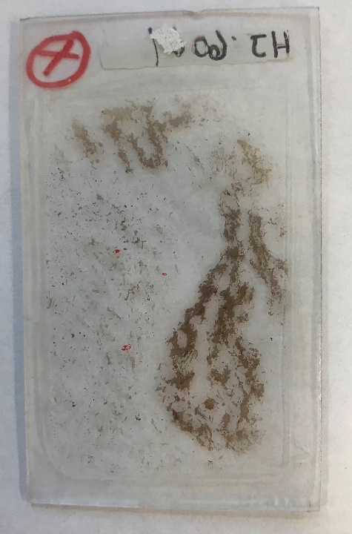
Minor phases: Rutile, muscovite, chlorite, sericite, oxides, opaques, monazite and zircon.
Microstructures:
Garnet is present as porphyroblasts, they are sub-rounded to elongate along the foliation. Some garnets are elongated (following sillimanite shape). Usually, it contains inclusions of sillimanite, biotite, quartz, or feldspar in a pool of felsic composition and polymineralic inclusions of quartz, feldspar, and biotite within a felsic pool. Some of the garnet rims are replaced by biotite and sillimanite clusters. Chlorite is filling fractures of some garnet grains.
Sillimanite is present as prismatic crystals forming clusters along the foliation, frequently with biotite in garnet replacement sites. It also occurs as fibrous inclusions in garnet.
Biotite forms large single laths or clusters, commonly with sillimanite, surrounding garnet and as smaller interstitial flakes in the quartzofeldspathic pods. Some biotite is being replaced by chlorite.
Quartz and feldspar show a relatively heterogeneous distribution with uniform grain size. K-feldspar shows perthitic texture. In addition, quartz, and feldspar form embayments in resorbed garnet and define finer microstructures including felsic pools and interstitial films. The felsic pools are found inside garnet and surrounding sillimanite. The interstitial films are preferentially in garnet grain boundaries with resorbed quartz.
5. HJ-60e:
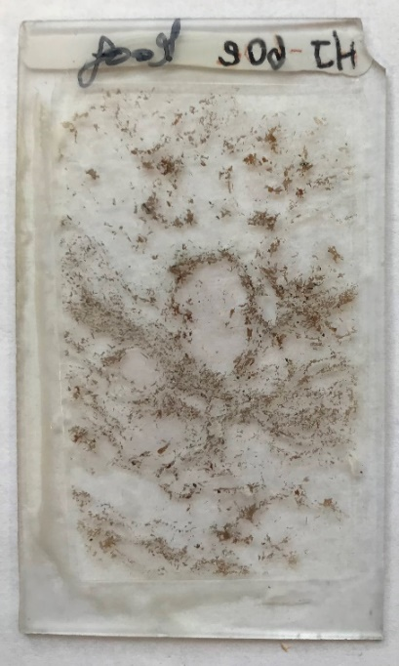
Variably disrupted network of garnet, biotite, and sillimanite elongated along the foliation, separated by quartzofeldspathic pods.
Main assemblage: Garnet, sillimanite, biotite, K-feldspar, plagioclase, and quartz.
Assemblage in the quartzofeldspathic pods: K-feldspar, plagioclase, quartz, biotite, and garnet.
Minor phases: Rutile, muscovite, chlorite, sericite, oxides, opaques, monazite, and zircon.
Microstructures:
Garnet is present as porphyroblasts, they are sub-rounded to elongated along the foliation. There are some smaller subhedral to euhedral grains. Usually, it contains inclusions of sillimanite, biotite, quartz, or feldspar in a pool of felsic composition and polymineralic inclusions of quartz, feldspar, and biotite within a felsic pool. Some of the garnet rims are replaced by biotite and sillimanite clusters.
Sillimanite is present as prismatic crystals forming clusters along the foliation, frequently with biotite in garnet replacement sites. It also occurs as fibrous inclusions in garnet.
Biotite forms large single laths or clusters, commonly with sillimanite, surrounding garnet and as smaller interstitial flakes in the quartzofeldspathic pods.
Quartz and feldspar show a relatively heterogeneous distribution with uniform grain size. K-feldspar shows perthitic texture. In addition, quartz, and feldspar form embayments in resorbed garnet and define finer microstructures including felsic pools and interstitial films. The felsic pools are found inside garnet and surrounding sillimanite. The interstitial films are preferentially in garnet grain boundaries with resorbed quartz.

6. HJ-60f:
Variably disrupted network of garnet, biotite, and sillimanite elongated along the foliation, separated by quartzofeldspathic pods.
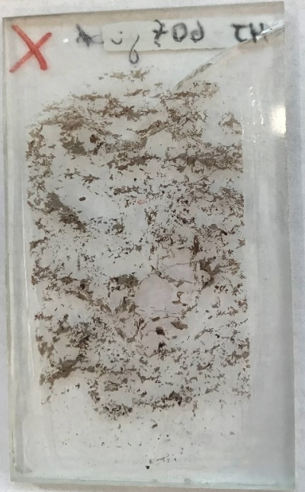
Main assemblage: Garnet, sillimanite, biotite, K-feldspar, plagioclase, and quartz.
Assemblage in the quartzofeldspathic pods: K-feldspar, plagioclase, quartz, biotite, and garnet.
Minor phases: Rutile, muscovite, chlorite, sericite, oxides, opaques, monazite, and zircon.
Microstructures:
Garnet is present as porphyroblasts, they are sub-rounded to elongated along the foliation. There are some smaller subhedral to euhedral grains. Usually, it contains inclusions of sillimanite, biotite, quartz, or feldspar in a pool of felsic composition and polymineralic inclusions of quartz, feldspar, and biotite within a felsic pool. Some of the garnet rims are replaced by biotite and sillimanite clusters.
Sillimanite is present as prismatic crystals forming clusters along the foliation, frequently with biotite in garnet replacement sites. It also occurs as fibrous inclusions in garnet.
Biotite forms large single laths or clusters, commonly with sillimanite, surrounding garnet and as smaller interstitial flakes in the quartzofeldspathic pods.
Quartz and feldspar show a relatively heterogeneous distribution with uniform grain size. K-feldspar shows perthitic texture. In addition, quartz, and feldspar form embayments in resorbed garnet and define finer microstructures including felsic pools and interstitial films. The felsic pools are found inside garnet and surrounding sillimanite. The interstitial films are preferentially in garnet grain boundaries with resorbed quartz.

7. HJ-60h:
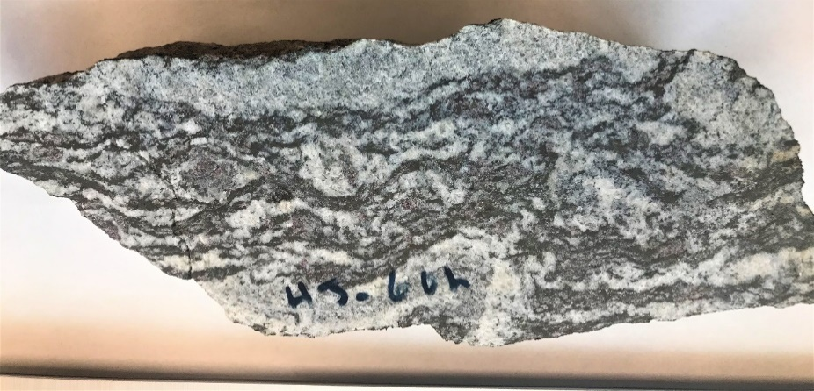
It consists of two domains: (a) A variably disrupted network of biotite and sillimanite elongated domains along the foliation, separated by quartzofeldspathic pods. (b) Two quartzofeldspathic layers with interstitial biotite and muscovite flakes.

Main assemblage: Garnet, sillimanite, biotite, K-feldspar, plagioclase, and quartz.
Assemblage in the quartzofeldspathic pods: K-feldspar, plagioclase, quartz, muscovite, biotite, and garnet.
Minor phases: Rutile, muscovite, chlorite, sericite, oxides, opaques, carbonates, monazite, and zircon.
Microstructures:
Garnet is present as porphyroblasts, they are sub-rounded to elongated along the foliation. There are some smaller subhedral to euhedral grains. Usually, it contains inclusions of sillimanite, biotite, quartz, or feldspar in a pool of felsic composition and polymineralic inclusions of quartz, feldspar, and biotite within a felsic pool. Some of the garnet rims are replaced by biotite and sillimanite clusters.
Sillimanite is present as prismatic crystals forming clusters along the foliation, frequently with biotite in garnet replacement sites. It also occurs as fibrous inclusions in garnet. Some sillimanite grains are completely replaced by a very fine flaky material (pinite/sericite.)
Biotite forms large single laths or clusters, commonly with sillimanite, surrounding garnet and as smaller interstitial flakes in the quartzofeldspathic pods. Some biotite is being replaced by chlorite.
Quartz and feldspar show a relatively heterogeneous distribution with uniform grain size. K-feldspar shows perthitic texture. In addition, quartz, and feldspar form embayments in resorbed garnet and define finer microstructures including felsic pools and interstitial films. The felsic pools are found inside garnet and surrounding sillimanite. The interstitial films are preferentially in garnet grain boundaries with resorbed quartz.
There is also the presence of an unidentified aluminum silicate, it is colorless, it shows low birefringence, the relief is not easily observed due to an alteration (pinite and sericite) at the rims and inside fractures of the mineral.
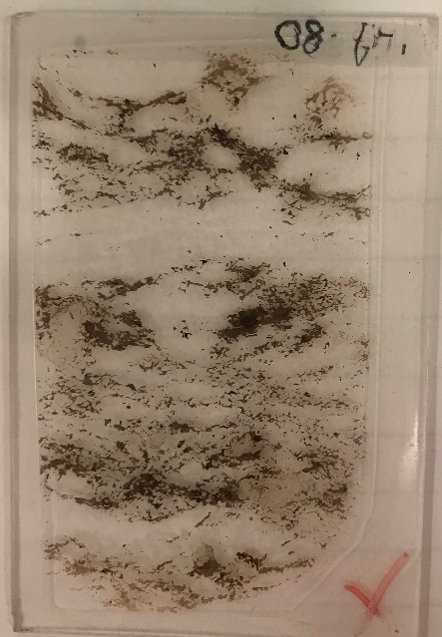
8. HJ-80:
Variably disrupted network of garnet, biotite, and sillimanite elongated along the foliation, separated by quartzofeldspathic pods.
Main assemblage: Garnet, biotite, K-feldspar, plagioclase, and quartz.
Assemblage in the quartzofeldspathic pods: K-feldspar, plagioclase, quartz, and biotite.
Minor phases: Muscovite, oxides, chlorite, sericite, opaques, monazite, and zircon.
Microstructures:
Garnet is present as porphyroblasts, they are sub-rounded to elongated along the foliation. There are some smaller subhedral to euhedral grains. Usually, it contains inclusions of sillimanite, biotite, quartz, or feldspar in a pool of felsic composition and polymineralic inclusions of quartz, feldspar, and biotite within a felsic pool. Some of the garnet rims are replaced by biotite and sillimanite clusters.
Sillimanite is present as prismatic crystals forming clusters along the foliation, frequently with biotite in garnet replacement sites. It also occurs as fibrous inclusions in garnet.
Biotite forms large single laths or clusters, commonly with sillimanite, surrounding garnet and as smaller interstitial flakes in the quartzofeldspathic pods.
Quartz and feldspar show a relatively heterogeneous distribution with uniform grain size. K-feldspar shows perthitic texture. In addition, quartz, and feldspar form embayments in resorbed garnet and define finer microstructures including felsic pools and interstitial films. The felsic pools are found inside garnet and surrounding sillimanite. The interstitial films are preferentially in garnet grain boundaries with resorbed quartz.

9. HJ-85:
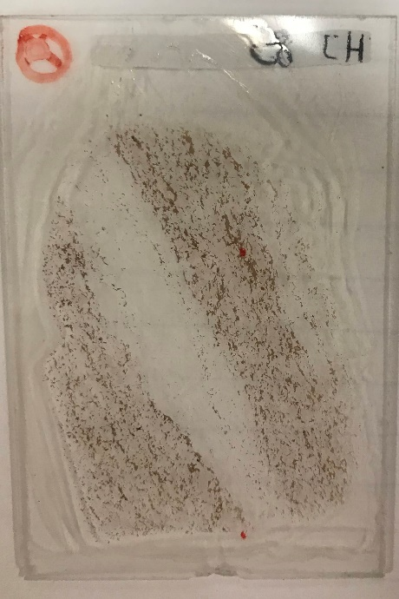
It consists of two domains: (a) Dark layers composed of biotite along with garnet porphyroblasts, and light-coloured quartzofeldspathic pods. (b) One predominant leucocratic layer composed of coarser quartz and feldspar with sporadic interstitial biotite flakes.
Main assemblage: Garnet, biotite, K-feldspar, plagioclase, and quartz.
Assemblage in the quartzofeldspathic pods: K-feldspar, plagioclase, quartz, and biotite.
Minor phases: Muscovite, oxides, chlorite, sericite, opaques, monazite, and zircon.
Microstructures:
Garnet is present as porphyroblasts, they are sub-rounded to elongated along the foliation. There are some smaller subhedral to euhedral grains. Usually, it contains inclusions of biotite, quartz, or feldspar in a pool of felsic composition and polymineralic inclusions of quartz, feldspar, and biotite within a felsic pool. Some of the garnet rims are replaced by biotite.
Biotite forms large single laths or clusters, commonly surrounding garnet and as smaller interstitial flakes in the quartzofeldspathic pods.
Quartz and feldspar show a relatively heterogeneous distribution with uniform grain size. K-feldspar shows perthitic texture. In addition, quartz, and feldspar form embayments in resorbed garnet and define finer microstructures including felsic pools and interstitial films. The felsic pools are found inside garnet .The interstitial films are preferentially in garnet grain boundaries with resorbed quartz.

10. HJ-88:
Variably disrupted network of biotite and sillimanite, separated by quartzofeldspathic pods
Main assemblage: Garnet, sillimanite, biotite, K-feldspar, plagioclase, and quartz.
Minor phases: Rutile, spinel, oxides, chlorite, sericite, opaques, monazite, and zircon.
Microstructures:
Garnet is present as porphyroblasts, they are sub-rounded to elongated along the foliation. Usually, it contains inclusions of sillimanite, biotite, quartz, or feldspar in a pool of felsic composition and polymineralic inclusions of quartz, feldspar, and biotite within a felsic pool. Some of the garnet rims are replaced by biotite and sillimanite clusters.
Sillimanite is present as prismatic crystals forming clusters along the foliation, frequently with biotite in garnet replacement sites. It also occurs as fibrous inclusions in garnet. Some sillimanite grains are completely replaced by a very fine flaky material (pinite/sericite.)
Biotite forms large single laths or clusters, commonly with sillimanite, surrounding garnet and as smaller interstitial flakes in the quartzofeldspathic pods. Some biotite is being replaced by chlorite.
Quartz and feldspar show a relatively heterogeneous distribution with uniform grain size. K-feldspar shows perthitic texture. In addition, quartz, and feldspar form embayments in resorbed garnet and define finer microstructures including felsic pools and interstitial films. The felsic pools are found inside garnet and surrounding sillimanite. The interstitial films are preferentially in garnet grain boundaries with resorbed quartz. Some feldspar grains are being altered.

HJ-88d series:
11. HJ-88d1:
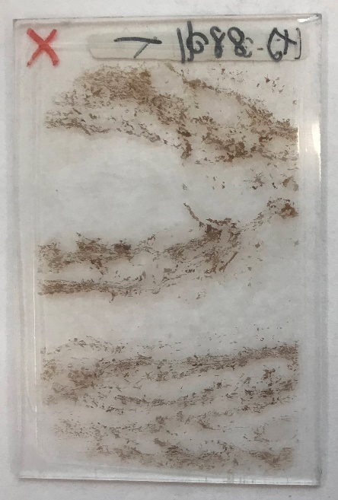
Dark aluminous network composed of sillimanite and biotite along with garnet porphyroblasts disrupted by quartzofeldspathic pods and light-coloured quartzofeldspathic layers. There are two predominant quartzofeldspathic layers composed of coarser quartz and feldspar with interstitial biotite flakes.
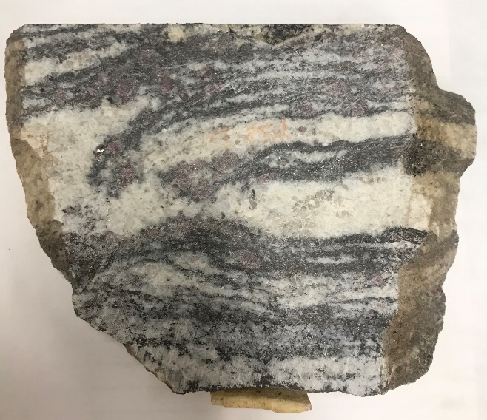
Main assemblage: Garnet, sillimanite, biotite, K-feldspar, plagioclase, and quartz.
Assemblage in the quartzofeldspathic pods: K-feldspar, plagioclase, quartz, and biotite.
Minor phases: Rutile, muscovite, oxides, chlorite, sericite, opaques, monazite and zircon.
Microstructures:
Garnet is present as porphyroblasts, they are sub-rounded to elongated along the foliation. There are some smaller subhedral to euhedral grains. Usually, it contains inclusions of sillimanite, biotite, quartz, or feldspar in a pool of felsic composition and polymineralic inclusions of quartz, feldspar, and biotite within a felsic pool. Some of the garnet rims are replaced by biotite and sillimanite clusters.
Sillimanite is present as prismatic crystals forming clusters along the foliation, frequently with biotite in garnet replacement sites. It also occurs as fibrous inclusions in garnet. Some sillimanite grains are completely replaced by a very fine flaky material (pinite/sericite.)
Biotite forms large single laths or clusters, commonly with sillimanite, surrounding garnet and as smaller interstitial flakes in the quartzofeldspathic pods and in the quartzofeldspathic layers. Some biotite is being replaced by chlorite.
Quartz and feldspar show a relatively heterogeneous distribution with uniform grain size. K-feldspar shows perthitic texture. In addition, quartz, and feldspar form embayments in resorbed garnet and define finer microstructures including felsic pools and interstitial films. The felsic pools are found inside garnet and surrounding sillimanite. The interstitial films are preferentially in garnet grain boundaries with resorbed quartz. Some feldspar grains are being altered.
There is also the presence of an unidentified aluminum silicate, it is colorless, it shows low birefringence, the relief is not easily observed due to an alteration (pinite and sericite) at the rims and inside fractures of the mineral.
12. HJ-88d2:
Dark aluminous network composed of sillimanite and biotite along with garnet porphyroblasts disrupted by quartzofeldspathic pods and light-coloured quartzofeldspathic layers. There are two predominant quartzofeldspathic layers composed of coarser quartz and feldspar with sporadic interstitial biotite flakes.
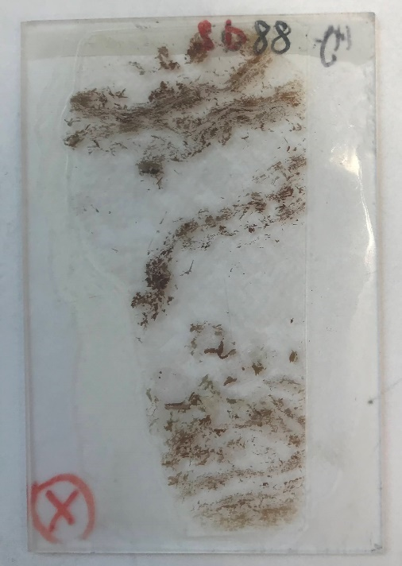
Main assemblage: Garnet, sillimanite, biotite, K-feldspar, plagioclase, and quartz.
Assemblage in the quartzofeldspathic pods: K-feldspar, plagioclase, quartz, and biotite.
Minor phases: Rutile, muscovite, oxides, chlorite, sericite, opaques, monazite, and zircon.
Microstructures:
Garnet is present as porphyroblasts, they are sub-rounded to elongated along the foliation. There are some smaller subhedral to euhedral grains. Usually, it contains inclusions of sillimanite, biotite, quartz, or feldspar in a pool of felsic composition and polymineralic inclusions of quartz, feldspar, and biotite within a felsic pool. Some of the garnet rims are replaced by biotite and sillimanite clusters.
Sillimanite is present as prismatic crystals forming clusters along the foliation, frequently with biotite in garnet replacement sites. It also occurs as fibrous inclusions in garnet. Some sillimanite grains are completely replaced by a very fine flaky material (pinite/sericite.)
Biotite forms large single laths or clusters, commonly with sillimanite, surrounding garnet and as smaller interstitial flakes in the quartzofeldspathic pods and in the quartzofeldspathic layers. Some biotite is being replaced by chlorite.
Quartz and feldspar show a relatively heterogeneous distribution with uniform grain size. K-feldspar shows perthitic texture. In addition, quartz, and feldspar form embayments in resorbed garnet and define finer microstructures including felsic pools and interstitial films. The felsic pools are found inside garnet and surrounding sillimanite. The interstitial films are preferentially in garnet grain boundaries with resorbed quartz. Some feldspar grains are being altered.
There is also the presence of an unidentified aluminum silicate, it is colorless, it shows low birefringence, the relief is not easily observed due to an alteration (pinite and sericite) at the rims and inside fractures of the mineral.
08-60 series:
13-) 08-60-1:
(a) It consists of alternating light-coloured quartzofeldspathic layers with darker layers composed of biotite and sporadic porphyroblasts of garnet. (b)There are two leucocratic layers with larger grains of quartz elongated along the foliation and feldspar. (c) Also, there is a a finer grain layer above composed of quartz, feldspar and interstitial biotite flakes.
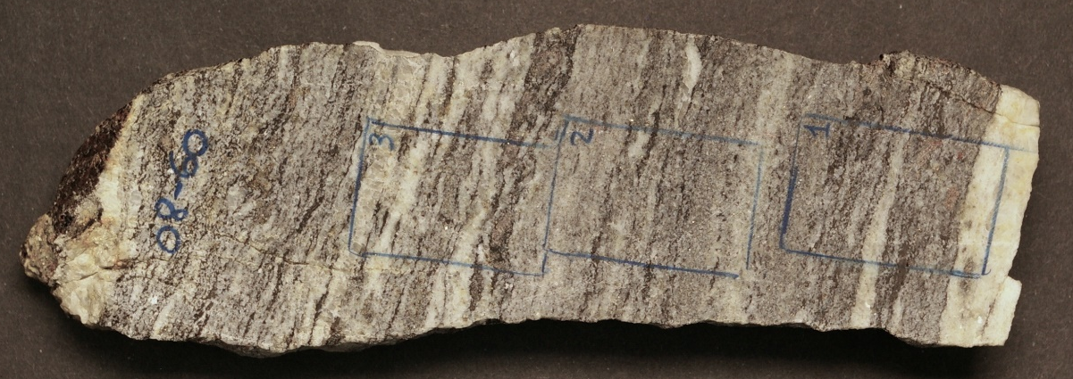
Main mineral assemblage: Biotite, K-feldspar, Plagioclase, Garnet, Quartz.
Assemblage in the quartzofeldspathic pods: K-feldspar, plagioclase, quartz, and biotite
Minor phases: Spinel, Sericite, Muscovite, Chlorite, Opaques, Monazite/Zircon.
Microstructures:
Garnet is present as porphyroblasts, they are sub-rounded to elongated along the foliation. There are some smaller subhedral to euhedral grains. Usually, it contains inclusions of sillimanite, biotite, quartz, or feldspar in a pool of felsic composition and polymineralic inclusions of quartz, feldspar, and biotite within a felsic pool. Some of the garnet rims are replaced by biotite. The boundaries of some garnet grains are being embayed by felsic pools.
Sillimanite is only present as fibrous inclusions in garnet.
Biotite forms large single laths or clusters, commonly surrounding garnet and as smaller interstitial flakes in quartzofeldspathic layers. Some grains are being embayed by felsic pods, and some biotite is filling fractures of garnet as well.
Quartz and feldspar show a relatively homogeneous distribution and grain size, except for some larger grains of quartz which are elongated along the foliation, in a leucocratic layer. K-feldspar displays perthitic texture. In addition, quartz, and feldspar form embayments in resorbed garnet and define finer microstructures including felsic pools and interstitial films. The felsic pools are found inside garnet. The interstitial films are preferentially in garnet grain boundaries with resorbed quartz. Some feldspar grains are being altered.
14-) 08-60-2:
Finer light-coloured quartzofeldspathic domains with interstitial biotite flakes, alternating with dark disrupted layers of biotite. There are sporadic garnets.
Main mineral assemblage: Biotite, K-feldspar, Plagioclase, Quartz ± Sillimanite.
Minor phases: Sericite, Muscovite, Chlorite, Opaques, Monazite/Zircon, apatite.
Microstructures:
Garnet is present as subhedral to anhedral small grains in the groundmass.
Sillimanite is only present as a single prismatic crystal in the groundmass.
Biotite forms large single laths or clusters, commonly surrounding garnet, and as smaller interstitial flakes in the quartzofeldspathic domains. Some grains are being embayed by felsic pods, and some biotite is filling fractures of garnet as well.
Quartz and feldspar show a relatively homogeneous distribution and grain size, except for some larger grains. They seem to be elongated along the foliation. K-feldspar displays perthitic texture. The boundaries of K-feldspar form embayments with the surrounding crystals (K-feldspar/quartz). Some feldspar grains are being altered.

15-) 08-60-3:
Fine dark aluminous network composed of biotite along with sporadic garnet disrupted by quartzofeldspathic pods and light-coloured quartzofeldspathic layers. There are three predominant quartzofeldspathic layers composed of coarser quartz and feldspar with sporadic interstitial biotite flakes.
Main mineral assemblage: Biotite, Garnet K-feldspar, Plagioclase, Quartz.
Assemblage in the quartzofeldspathic pods: K-feldspar, plagioclase, quartz, and biotite
Minor phases: Sericite, Muscovite, Chlorite, Opaques, Monazite/Zircon, apatite.
Microstructures:
Garnet is present as porphyroblasts, they are sub-rounded to elongate along the foliation. There are some smaller subhedral to euhedral grains. Usually, it contains inclusions of sillimanite, biotite, quartz, or feldspar in a pool of felsic composition and polymineralic inclusions of quartz, feldspar, and biotite within a felsic pool. Some of the garnet rims are replaced by biotite. The boundaries of some garnet grains are being embayed by felsic pools.
Sillimanite is present as fibrous inclusions in garnet and as few prismatic crystals in the groundmass.
Biotite forms large single laths or clusters, commonly surrounding garnet, and as smaller interstitial flakes in the groundmass. Some grains are being embayed by felsic pods.
Quartz and feldspar show a relatively homogeneous distribution and grain size, except for some larger grains. They seem to be elongated along the foliation, especially the grains belonging to the quartzofeldspathic layers. K-feldspar displays perthitic texture. The boundaries of K-feldspar form embayments with the surrounding crystals (K-feldspar/quartz). Some feldspar grains are being altered.

08-60a series:
16-) 08-60a-1
It consists of four main domains: (a) A coarser dark aluminous network composed of biotite and sillimanite along with garnet porphyroblasts, and light-coloured quartzofeldspathic pods. (b) A finer network composed of biotite (clusters and individual grains), some clusters are surrounding large garnet porphyroblasts and are disrupted by quartzofeldspathic pods. (c) There are two predominant leucocratic layers composed of coarser quartz and feldspar, with interstitial biotite flakes. (d) A finer layer composed of quartzofeldspathic minerals and interstitial biotite.
Main mineral assemblage: Biotite, Sillimanite, Garnet K-feldspar, Plagioclase, Quartz.
Assemblage in the quartzofeldspathic pods: K-feldspar, plagioclase, quartz, and biotite
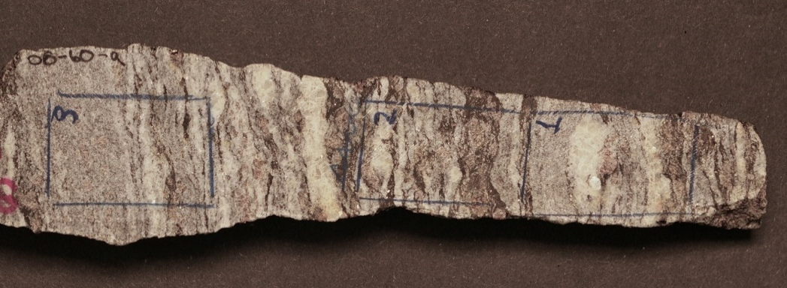
Minor phases: Sericite, Muscovite, Chlorite, Opaques, Monazite/Zircon.
Microstructures:
Garnet is present as porphyroblasts, they are sub-rounded to elongate along the foliation. There are some smaller anhedral to euhedral grains. Usually, it contains inclusions of sillimanite, biotite, quartz, or feldspar in a pool of felsic composition and polymineralic inclusions of quartz, feldspar, and biotite within a felsic pool. Some of the garnet rims are replaced by biotite and sillimanite clusters. The boundaries of some garnet grains are being embayed by felsic pools.
Sillimanite is present as prismatic crystals forming clusters along the foliation, frequently with biotite in garnet replacement sites. It also occurs as fibrous inclusions in garnet.
Biotite forms large single laths or clusters, commonly surrounding garnet, and as smaller interstitial flakes in the quartzofeldspathic layers. Some grains are being embayed by felsic pods.
Quartz and feldspar show a relatively homogeneous distribution and grain size, except for some larger grains of K-feldspar and quartz from the quartzofeldspathic layers. They seem to be elongated along the foliation, especially the grains belonging to the quartzofeldspathic layers. K-feldspar displays perthitic texture. Some K-feldspar boundaries form embayments with the surrounding crystals (K-feldspar/quartz). Some feldspar grains are being altered.
17-) 08-60a-2:
Fine dark aluminous network composed of biotite and sillimanite along with sporadic garnet disrupted by quartzofeldspathic pods and light-coloured quartzofeldspathic layers. There are leucocratic layers composed of coarser quartz and feldspar, with interstitial biotite flakes.
Main mineral assemblage: Biotite, Sillimanite, Garnet K-feldspar, Plagioclase, Quartz.
Assemblage in the quartzofeldspathic pods: K-feldspar, plagioclase, quartz, and biotite
Minor phases: Sericite, Muscovite, Chlorite, Opaques, Monazite/Zircon.
Microstructures:
Garnet is present as porphyroblasts, they are sub-rounded to elongate along the foliation. There are some smaller anhedral to euhedral grains. Usually, it contains inclusions of sillimanite, biotite, quartz, or feldspar in a pool of felsic composition and polymineralic inclusions of quartz, feldspar, and biotite within a felsic pool. Some of the garnet rims are replaced by biotite and sillimanite clusters. The boundaries of some garnet grains are being embayed by felsic pools.
Sillimanite is present as prismatic crystals forming clusters along the foliation, frequently with biotite in garnet replacement sites. It also occurs as fibrous inclusions in garnet.
Biotite forms large single laths or clusters, commonly surrounding garnet, and as smaller interstitial flakes in the quartzofeldspathic layers. Some grains are being embayed by felsic pods.
Quartz and feldspar show a relatively homogeneous distribution and grain size, except for some larger grains of K-feldspar and quartz from the quartzofeldspathic layers. They seem to be elongated along the foliation, especially the grains belonging to the quartzofeldspathic layers. K-feldspar displays perthitic texture. Some K-feldspar boundaries form embayments with the surrounding crystals (K-feldspar/quartz). Some feldspar grains are being altered.

18-) 08-60a-3:
It consists of three main domains: (a) A coarser dark aluminous network composed of biotite along with garnet porphyroblasts, and light-coloured quartzofeldspathic pods. (c) Leucocratic layers composed of coarser quartz and feldspar, with interstitial biotite flakes. (d) A finer layer composed of quartzofeldspathic minerals and interstitial biotite.
Main mineral assemblage: Biotite, Garnet K-feldspar, Plagioclase, Quartz.
Assemblage in the quartzofeldspathic pods: K-feldspar, plagioclase, quartz, and biotite
Minor phases: Opaques, Monazite/Zircon.
Microstructures:
Garnet is present as porphyroblasts, they are sub-rounded to elongate along the foliation. There are some smaller anhedral to euhedral grains. Usually, it contains inclusions of biotite, quartz, or feldspar in a pool of felsic composition and polymineralic inclusions of quartz, feldspar, and biotite within a felsic pool. Some of the garnet rims are replaced by biotite.The boundaries of some garnet grains are being embayed by felsic pools.
Biotite forms large single laths or clusters, commonly surrounding garnet, and as smaller interstitial flakes in the quartzofeldspathic layers. Some grains are being embayed by felsic pods.
Quartz and feldspar show a relatively homogeneous distribution and grain size, except for some larger grains of K-feldspar and quartz from the quartzofeldspathic layers. They seem to be elongated along the foliation, especially the grains belonging to the quartzofeldspathic layers. K-feldspar displays perthitic texture. Some K-feldspar boundaries form embayments with the surrounding crystals (K-feldspar/quartz). Some feldspar grains are being altered.

08-65 series:
19-) 08-65-A
It consists of domains composed of felsic material: quartz and feldspar, with some garnet porphyroblasts.
Main mineral assemblage: Biotite, garnet, k-feldspar, plagioclase, quartz.
Minor phases: Muscovite, sericite, opaques, monazite/zircon.
Microstructures:
Garnet is present as porphyroblasts, they are sub-rounded to elongate along the foliation. There are some smaller anhedral to euhedral grains. The porphyroblasts contains inclusions of biotite and quartz or feldspar inside pools of felsic composition. The rims of the porphyroblasts are being replaced by chlorite clusters.
Biotite forms large single laths or clusters, commonly surrounding garnet. Biotite is being replaced by chlorite.
Quartz and feldspar show a relatively homogeneous distribution and grain size, except for some smaller grains. They seem to be elongated along the foliation. K-feldspar displays perthitic texture. Some K-feldspar boundaries form embayments with the surrounding crystals (K-feldspar/quartz). There are interstitial felsic films between grain boundaries. Quartz contains inclusions of feldspar, and polymineral inclusions of garnet biotite and feldspar.

20-) 08-65-A1
It consists of domains composed of felsic material: quartz and feldspar, alternating with darker thin layers of biotite and garnet porphyroblasts.
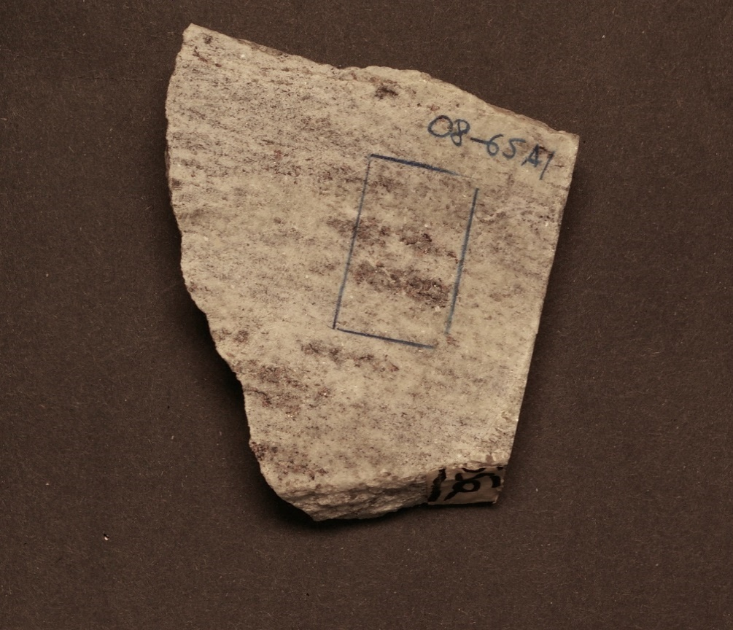

Main mineral assemblage: Biotite, garnet, k-feldspar, plagioclase, quartz.
Minor phases: Muscovite, sericite, opaques, monazite/zircon.
Microstructures:
Garnet is present as porphyroblasts, they are sub-rounded to elongate along the foliation. There are some smaller anhedral to euhedral grains. The porphyroblasts contains inclusions of biotite and quartz or feldspar inside pools of felsic composition. The rims of the porphyroblasts are being replaced by chlorite clusters.
Biotite forms large single laths or clusters, commonly surrounding garnet and as smaller interstitial flakes. Biotite is being replaced by chlorite.
Quartz and feldspar show a relatively homogeneous distribution and grain size, except for some smaller grains. They seem to be elongated along the foliation. K-feldspar displays perthitic texture. Some K-feldspar boundaries form embayments with the surrounding crystals (K-feldspar/quartz). There are interstitial felsic films between grain boundaries.

21-) 08-66
Variably disrupted network of biotite, garnet and sillimanite , separated by quartzofeldspathic pods, and light-coloured quartzofeldspathic layers. There is one leucocratic layer composed of coarser quartz and perthitic feldspar.
Main assemblage: Garnet, sillimanite, biotite, K-feldspar, plagioclase, and quartz.
Minor phases: Monazite, sericite, oxides, and opaques.
Microstructures:
Garnet is present as porphyroblasts, they are sub-rounded to elongated along the foliation. Usually, it contains inclusions of sillimanite, biotite, quartz, or feldspar in a pool of felsic composition and polymineralic inclusions of quartz, feldspar, and biotite within a felsic pool. Some of the garnet rims are replaced by biotite and sillimanite clusters.
Sillimanite is present as prismatic crystals forming clusters along the foliation, frequently with biotite in garnet replacement sites. It also occurs as fibrous inclusions in garnet.
Biotite forms large single laths or clusters, commonly with sillimanite, surrounding garnet and as smaller interstitial flakes in the quartzofeldspathic pods. Some biotite is being replaced by chlorite.
Quartz and feldspar show a relatively homogeneous distribution with uniform grain size, except for the coarser leucocratic layer. K-feldspar shows perthitic texture. Quartz and feldspar form embayments in resorbed garnet and define finer microstructures including felsic pools and interstitial films. The felsic pools are found inside garnet and surrounding sillimanite. The interstitial films are preferentially in garnet grain boundaries with resorbed quartz. Some feldspar grains are being altered.
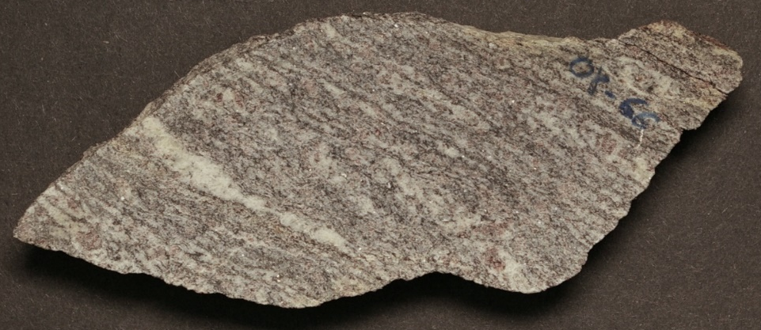

08-67 series:
22-) 08-67-1
It consists of dominantly quartzofeldspathic layers with interstitial biotite flakes, disrupted by with sporadic darker aluminous domains composed of biotite, sillimanite and garnet.
Main assemblage: Garnet, sillimanite, biotite, K-feldspar, plagioclase, and quartz.
Assemblage in the quartzofeldspathic pods: K-feldspar, plagioclase, quartz, and biotite
Minor phases: Muscovite, chlorite, monazite, sericite, oxides and opaques.
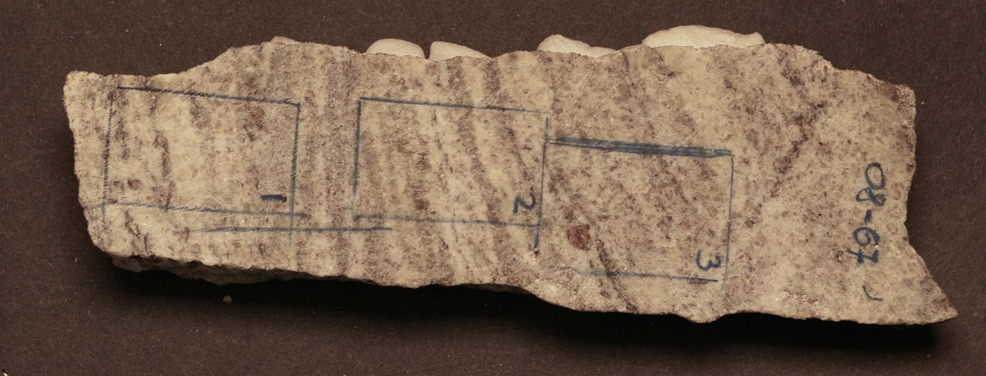
Microstructures:
Garnet is present as porphyroblasts, they are sub-rounded to elongated along the foliation, and as smaller anhedral to subhedral grains. Usually, it contains inclusions of sillimanite, biotite, quartz, or feldspar in a pool of felsic composition and polymineralic inclusions of quartz, feldspar, and biotite within a felsic pool. Some of the garnet rims are replaced by biotite and sillimanite clusters.
Sillimanite is present as prismatic crystals forming clusters along the foliation, frequently with biotite in garnet replacement sites. It also occurs as fibrous inclusions in garnet.
Biotite forms large single laths or clusters, commonly with sillimanite, surrounding garnet and as smaller interstitial flakes in the quartzofeldspathic pods. Some biotite is being replaced by chlorite.
Quartz and feldspar show a homogeneous distribution and grain size, except for some smaller grains belonging to the finer top layer of the section. They seem to be elongated along the foliation. K-feldspar displays perthitic texture. Quartz and feldspar form embayments in resorbed garnet and define finer microstructures including felsic pools and interstitial films. The felsic pools are found inside garnet and surrounding sillimanite. The interstitial films are preferentially in garnet grain boundaries with resorbed quartz. Some feldspar grains are being altered.

23-) 08-67-2
It consists of domains composed of felsic material: quartz and feldspar with sporadic garnet prophyroblasts and biotite discontinuos layers.
Main assemblage: Garnet, biotite, K-feldspar, plagioclase, and quartz (±Sillimanite).
Minor phases: Muscovite, chlorite, monazite, sericite, oxides and opaques.
Microstructures:
Garnet is present as porphyroblasts, they are sub-rounded to elongated along the foliation, and as smaller anhedral to subhedral grains. Usually, it contains inclusions of sillimanite and biotite. Some garnet fractures are filled with chlorite.
Biotite forms large single laths or clusters, commonly surrounding garnet and as smaller interstitial flakes. Some biotite grains are being replaced by chlorite.
Sillimanite is present as fibrous inclusions in garnet.
Quartz and feldspar show a relatively heterogenous grain size, the majority are smaller grains except for some coarser layers. They seem to be elongated along the foliation. K-feldspar displays perthitic texture. Some K-feldspar boundaries form embayments with the surrounding crystals (K-feldspar/quartz). There are interstitial felsic films between grain boundaries.

24-) 08-67-3
It consists of domains composed of felsic material: quartz and feldspar with sporadic garnet prophyroblasts and biotite discontinuos layers
Main assemblage: Garnet, biotite, K-feldspar, plagioclase, and quartz. (±Sillimanite)
Minor phases: Muscovite, chlorite, monazite, sericite, oxides and opaques.
Microstructures:
Garnet is present as porphyroblasts, they are sub-rounded to elongated along the foliation, and as smaller anhedral to subhedral grains. Usually it contains inclusions of biotite, pools of quartz or feldspar.
Biotite forms large single laths or clusters, commonly surrounding garnet, and as smaller interstitial flakes in the groundmass. Some grains are being embayed by felsic pods.
Sillimanite is present as fibrous inclusions in garnet.
Quartz and feldspar show a relatively heterogenous grain size, the majority are smaller grains except for some coarser layers. They seem to be elongated along the foliation. K-feldspar displays perthitic texture. Some K-feldspar boundaries form embayments with the surrounding crystals (K-feldspar/quartz). There are interstitial felsic films between grain boundaries. K-feldspar and plagioclase are being altered.

