Appendix A3. Slab and SEM-MLA sample 08-60

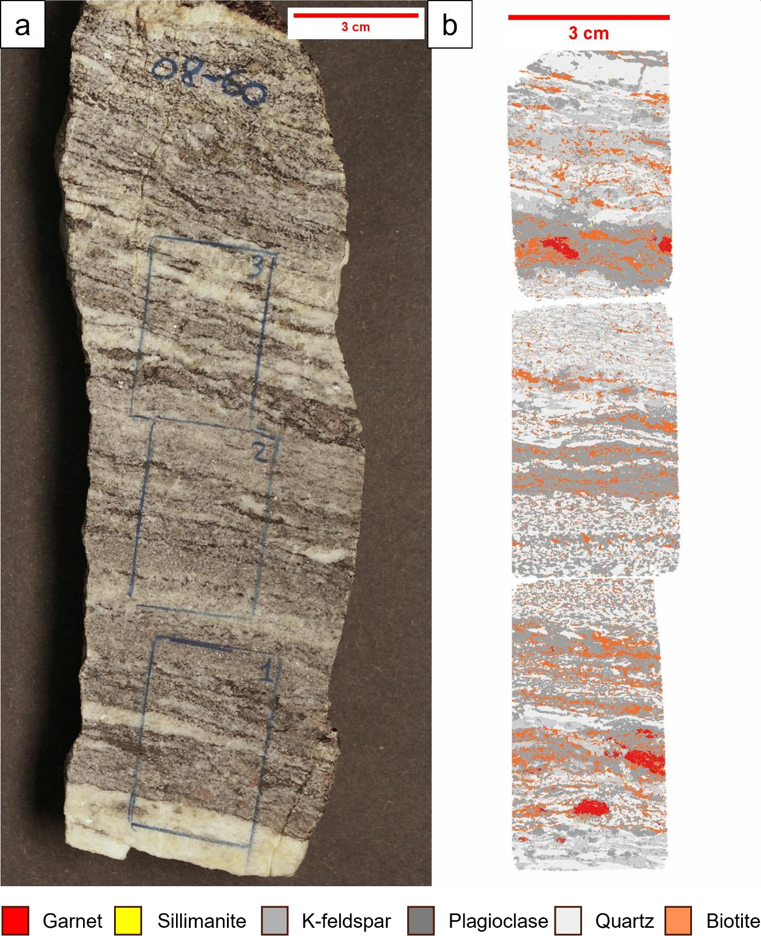
a) Slab of sample 08-60, from the PLV1, displaying varying ratios between quartzofeldspathic and aluminous domains, along with different distribution of grain size. b) SEM-MLA map generated for the same slab with three thin sections of sample 08-60.

