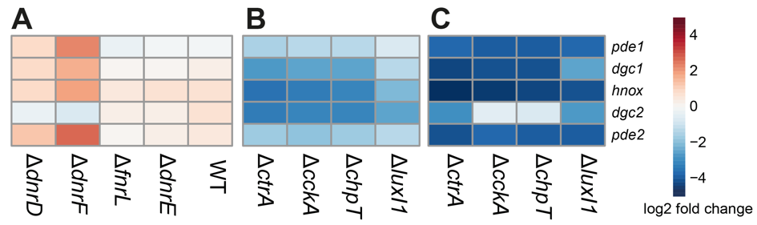
Figure S2.1. Transcript level changes of D. shibae c-di-GMP signaling genes. The transcript levels of the c-di-GMP-related genes was observed in four Crp/Fnr mutants and the wild type under anaerobic growth conditions as compared to aerobic growth (A), and in knockout strains of luxI₁ and the CtrA phosphorelay components during logarithmic (B) and stationary (C) phases of growth compared to the wild type.
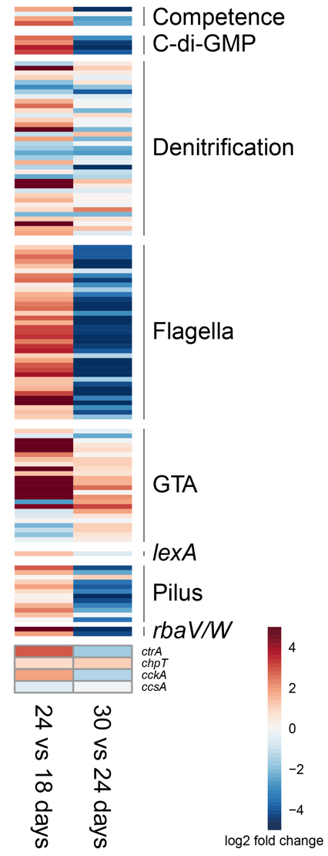
Figure S2.2. Comparison of changes in transcript levels during different stages of the “Jekyll and Hyde” interaction between Dinoroseobacter shibae and the dinoflagellate Prorocentrum minimum. Changes in transcript levels for selected gene groups in D. shibae during the mutualistic (18 days) relative to transition (24 days) phases and transition relative to pathogenic (30 days) phases of cocultivation with P. minimum are shown.
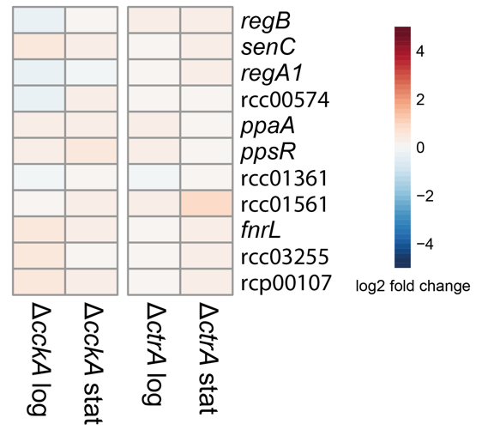
Figure S2.3. Transcript level changes of various FnrL- and RegA-related genes in CtrA phosphorelay mutants during exponential and stationary phases of growth in Rhodobacter capsulatus.

