Supplementary Materials

Table S.1. Mean proportion (%) of each of the 43 dominant fatty acids found in the six animal species, two macroalgal species, and two environmental components (see Table 1 for species list) sampled inside (I) or outside (O) of the South site (see Figure 1A). Each component’s highest FA proportion is bolded. Asterisks (*) denote fatty acids that altogether contribute to at least 70% similarity in each food web component (Table B.1). FA are listed in ascending order of retention time from the 30-m long ZB wax+ (Phenomenex) GC column in the Varian Galaxie Chromatography Data System (see section 2.6 for details).

 | A. rubens  (I; N=3) | H. arctica  (I; N=3) | Nereis spp.  (I; N=3) | O. aculeata  (I; N=3) | S. droebachiensis  (I; N=2) | Tonicella spp.  (I; N=3) | L. digitata  (O; N=2) | L. glaciale  (I) | Seawater  (O; N=3) | Sediment  (I; N=3)
FA | % (±SD) | % (±SD) | % (±SD) | % (±SD) | % (±SD) | % (±SD) | % (±SD) | % (±SD) | % (±SD) | % (±SD)
14:0 | 0.6 (0.2) | 4.3 (1.1)* | 1.2 (0.4) | 6.5 (1.3)* | 3.2 (1.2) | 3.6 (0.4)* | 5.2 (0.5) | N/A | 0.9 (0.4) | 1.7 (0.8)
TMTD† | 0.1 (0) | 0.4 (0.3) | 0 (0) | 0 (0) | 0.1 (0) | 1.2 (0.1) | 0 (0) | N/A | 0.2 (0.1) | 0 (0)
i15:0 | 0.1 (0.1) | 0.4 (0.1) | 0.1 (0) | 0.1 (0) | 0.2 (0.1) | 0.3 (0) | 0.4 (0.1) | N/A | 0.1 (0.1) | 1.4 (0.4)
ai15:0 | 0.1 (0.1) | 0.2 (0.2) | 0.1 (0) | 0.1 (0) | 0.2 (0.1) | 0.2 (0) | 0 (0) | N/A | 0 (0.1) | 2.5 (0.4)
15:0 | 0.3 (0) | 0.4 (0.1) | 0.8 (0.1) | 0.2 (0) | 0.4 (0.1) | 0.8 (0.1) | 0.2 (0) | N/A | 0.1 (0.1) | 0.8 (0.1)
i16:0 | 0.3 (0) | 0.2 (0.2) | 0.1 (0) | 0 (0) | 0.1 (0) | 0.2 (0) | 0 (0) | N/A | 0 (0) | 0.4 (0.4)
ai16:0 | 0.2 (0.1) | 0.1 (0.1) | 0.3 (0.1) | 0 (0) | 0.1 (0.2) | 0.3 (0.4) | 0 (0.1) | N/A | 0 (0) | 1.1 (0.9)
16:0 | 4.2 (1.6) | 16.5 (1.1)* | 11.1 (0.6)* | 15.5 (14.2)* | 8.8 (0.5)* | 10.9 (0.8)* | 17.5 (1.2)* | N/A | 21.7 (2.8)* | 14.6 (0.4)*
16:1ω11 | 0 (0) | 0.2 (0.1) | 0.1 (0.1) | 0.1 (0.1) | 0.3 (0.2) | 0.1 (0) | 0.8 (0.3) | N/A | 0.1 (0) | 3.1 (1.7)
16:1ω9 | 0.1 (0.1) | 0.3 (0.1) | 0.1 (0.1) | 0.1 (0) | 0.3 (0.1) | 0.3 (0) | 0 (0) | N/A | 0 (0) | 0.9 (0.6)
16:1ω7 | 1.8 (0.5) | 12.7 (0.9)* | 3.4 (1.0) | 5.9 (0.9*) | 4.1 (1.6)* | 8.1 (0.4)* | 2.4 (0) | N/A | 1.2 (0.2) | 20.6 (1.0)*
16:1ω5 | 0.1 (0.1) | 0.6 (0) | 0.3 (0) | 0.1 (0) | 0.4 (0.1) | 0.2 (0) | 0.1 (0) | N/A | 0 (0) | 1.4 (0.1)
i17:0 | 0.3 (0.1) | 0.8 (0.4) | 0.3 (0) | 0.3 (0.1) | 0.4 (0) | 0.2 (0) | 1.7 (0.1) | N/A | 0.2 (0.1) | 0.8 (0.2)
ai17:0 | 0.3 (0.2) | 0.5 (0.3) | 0.3 (0) | 0.3 (0.1) | 0.4 (0.1) | 0.6 (0.1) | 0.3 (0) | N/A | 0 (0) | 1.2 (0.4)
16:2ω4 | 0.1 (0.1) | 0.8 (0.1) | 0.1 (0) | 0.8 (0.2) | 0.9 (0.5) | 0.8 (0.1) | 0.2 (0) | N/A | 0 (0) | 1.0 (0.1)
17:0 | 0.5 (0.1) | 0.4 (0.1) | 1.4 (0.2) | 0.1 (0.1) | 0.1 (0) | 0.4 (0.1) | 0.1 (0) | N/A | 0.1 (0.1) | 0.6 (0.1)
16:3ω4 | 0 (0) | 0.2 (0.1) | 0 (0) | 1.0 (0.6) | 0.7 (0.5) | 0.8 (0.3) | 0 (0) | N/A | 0 (0) | 2.5 (0.2)*

Table S.1. (continued):
 |  |  | A. rubens  (I; N=3) | H. arctica  (I;N=3) | Nereis spp.  (I; N=3) | O. aculeata  (I; N=3) | S. droebachiensis  (I; N=2) | Tonicella spp.  (I; N=3) | L. digitata  (O; N=2) | L. glaciale  (I) | Seawater  (O; N=3) | Sediment  (I; N=3)
FA |  |  | % (±SD) | % (±SD) | % (±SD) | % (±SD) | % (±SD) | % (±SD) | % (±SD) | % (±SD) | % (±SD) | % (±SD)
17:1 |  |  | 9.2 (6.3)* | 1.2 (0.2) | 1.0 (0.5) | 1.1 (1.0) | 1.1 (0.5) | 0.6 (0.6) | 0.7 (0) | N/A | 0 (0) | 1.0 (0.2)
16:4ω3 |  |  | 1.4 (2.3) | 0.1 (0.1) | 3.1 (0.6) | 0 (0) | 0.8 (1.2) | 1.4 (0.5) | 0 (0) | N/A | 0 (0.1) | 0.3 (0.4)
16:4ω1 |  |  | 0 (0.1) | 0.4 (0.3) | 0.1 (0.1) | 4.4 (2.0) | 1.0 (0.4) | 0.7 (0.1) | 0.2 (0) | N/A | 0.7 (0.2) | 2.3 (2.7)
18:0 |  |  | 5.9 (0.8)* | 2.7 (0) | 4.1 (0.4)* | 4.0 (0.6) | 2.7 (0.2) | 3.0 (0.8) | 0.7 (0.1) | N/A | 18.2 (2.5)* | 3.5 (3.1)
18:1ω11 |  |  | 0.1 (0.1) | 0.6 (0.4) | 5.3 (0.2)* | 1.8 (0.2) | 0.5 (0) | 0.2 (0.1) | 0 (0) | N/A | 0 (0) | 0 (0.1)
18:1ω9 |  |  | 0.5 (0.5) | 1.7 (1.0) | 2.2 (0.6) | 0.9 (0.1) | 1.3 (0.4) | 9.0 (1.2)* | 13.0 (0.2)* | N/A | 32.9 (12.1)* | 5.3 (1.6)*
18:1ω7 |  |  | 2.6 (1.5) | 7.0 (1.4)* | 6.3 (0.3)* | 6.6 (0.9)* | 3.5 (0.2)* | 6.8 (0.4)* | 0.1 (0.1) | N/A | 2.0 (1.8) | 9.0 (0.6)*
18:2ω6 (LA) |  |  | 0.1 (0.1) | 1.9 (0.3) | 1.3 (0.2) | 2.6 (0.5) | 2.2 (1.6) | 0.3 (0) | 9.1 (0.2)* | N/A | 5.3 (2.0) | 1.3 (0.5)
18:2ω4 |  |  | 0 (0) | 0.7 (0.1) | 0.2 (0) | 0.5 (0.1) | 0.3 (0.1) | 0.5 (0.4) | 0 (0) | N/A | 0 (0) | 0 (0.1)
18:3ω6 (GLA) |  |  | 0.6 (0.6) | 0.2 (0.1) | 0 (0) | 0.4 (0.1) | 0.4 (0.0) | 0.4 (0.2) | 0.6 (0) | N/A | 0 (0) | 0.3 (0.2)
18:3ω3 (ALA) |  |  | 0 (0) | 0.8 (0) | 0.8 (0.2) | 0.5 (0.1) | 1.2 (0.2) | 0.5 (0.1) | 7.5 (0) | N/A | 0 (0) | 1.1 (0.3)
18:4ω3 (OTA) |  |  | 0.3 (0.6) | 4.5 (1.8) | 0.5 (0.2) | 5.1 (1.8)* | 3.8 (1.1)* | 1.3 (0.2) | 8.0 (0.4)* | N/A | 0.4 (0.4) | 1.3 (0.5)
19:3 |  |  | 0 (0) | 0 (0) | 2.6 (0.6) | 0 (0) | 0 (0) | 0 (0) | 0.1 (0.1) | N/A | 0 (0) | 0 (0)
20:0 |  |  | 0 (0) | 0 (0.1) | 0 (0) | 0.4 (0.2) | 1.1 (0.4) | 0 (0) | 0 (0) | N/A | 0.3 (0.3) | 0.4 (0.1)
20:1ω11 |  |  | 3.3 (5.7) | 0.6 (0.1) | 1.6 (0.2) | 5.2 (0.9)* | 0 (0) | 1.0 (0.6) | 0 (0) | N/A | 0 (0) | 0.4 (0.2)
20:1ω9 |  |  | 4.8 (0.4) | 0.8 (0.1) | 0.8 (0.3) | 0.1 (0.1) | 1.9 (0.2) | 1.2 (1.1) | 0 (0) | N/A | 0.7 (0.6) | 0.1 (0.1)
20:1ω7 |  |  | 0.7 (1.2) | 1.6 (1.4) | 0.5 (0.1) | 1.4 (0.3) | 1.5 (0) | 0.1 (0.1) | 0 (0) | N/A | 0 (0) | 0.1 (0.1)
20:2ω6 |  |  | 1.8 (0.3) | 1.5 (0.4) | 1.8 (0.4) | 0.3 (0.3) | 3.1 (0.3)* | 1.5 (0) | 0.7 (0) | N/A | 0 (0) | 1.2 (0.2)
20:4ω6 (ARA) |  |  | 19.8 (6.3)* | 0.6 (0.6) | 3.2 (1.6) | 0.9 (0.1) | 14.5 (2.5)* | 4.9 (4.2) | 0.1 (0.1) | N/A | 0 (0) | 3.7 (0.4)*
20:3ω3 |  |  | 0.3 (0.3) | 0.1 (0) | 1.0 (0.6) | 0.1 (0.1) | 2.1 (1.3) | 0.2 (0.2) | 0.6 (0) | N/A | 0 (0) | 0 (0)
20:4ω3 |  |  | 0.1 (0.2) | 0.7 (0.1) | 0.3 (0.1) | 0.4 (0.1) | 1.8 (1.5) | 0.8 (0.1) | 13.5 (0.8)* | N/A | 0 (0) | 0 (0)
20:5ω3 (EPA) |  |  | 31.6 (1.6)* | 19.3 (3.5)* | 29.3 (4.4)* | 26.8 (5.5)* | 24.8 (2.3)* | 21.8 (0.5)* | 0 (0) | N/A | 1.2 (0.5) | 7.8 (0.9)*
21:5ω3 |  |  | 0.1 (0.1) | 1.5 (0.3) | 0 (0) | 0.8 (0.1) | 0.3 (0.2) | 0.5 (0) | 0 (0) | N/A | 0 (0) | 0 (0)
22:4ω6 |  |  | 0.1 (0.1) | 1.0 (0.7) | 4.8 (1.9)* | 0 (0) | 0.2 (0) | 2.8 (0.3) | 0 (0) | N/A | 0 (0) | 0 (0)
22:5ω3 (DPA) |  |  | 0.1 (0.2) | 1.5 (0.6) | 4.8 (1.3)* | 0.3 (0.2) | 0.3 (0.1) | 4.7 (0.3)* | 0 (0) | N/A | 0 (0) | 0.9 (1.0)
22:6ω3 (DHA) |  |  | 5.3 (2.9) | 8.9 (1.0)* | 1.0 (0.3) | 0.6 (0.1) | 1.5 (0.6) | 0.6 (0) | 0 (0) | N/A | 1.0 (0.2) | 1.4 (0.6)
Total |  |  | 97.8 | 98.5 | 93.7 | 98.7 | 92.7 | 93.9 | 83.7 | N/A | 87.5 | 96.1
 | † Trimethyltridecanoic acid

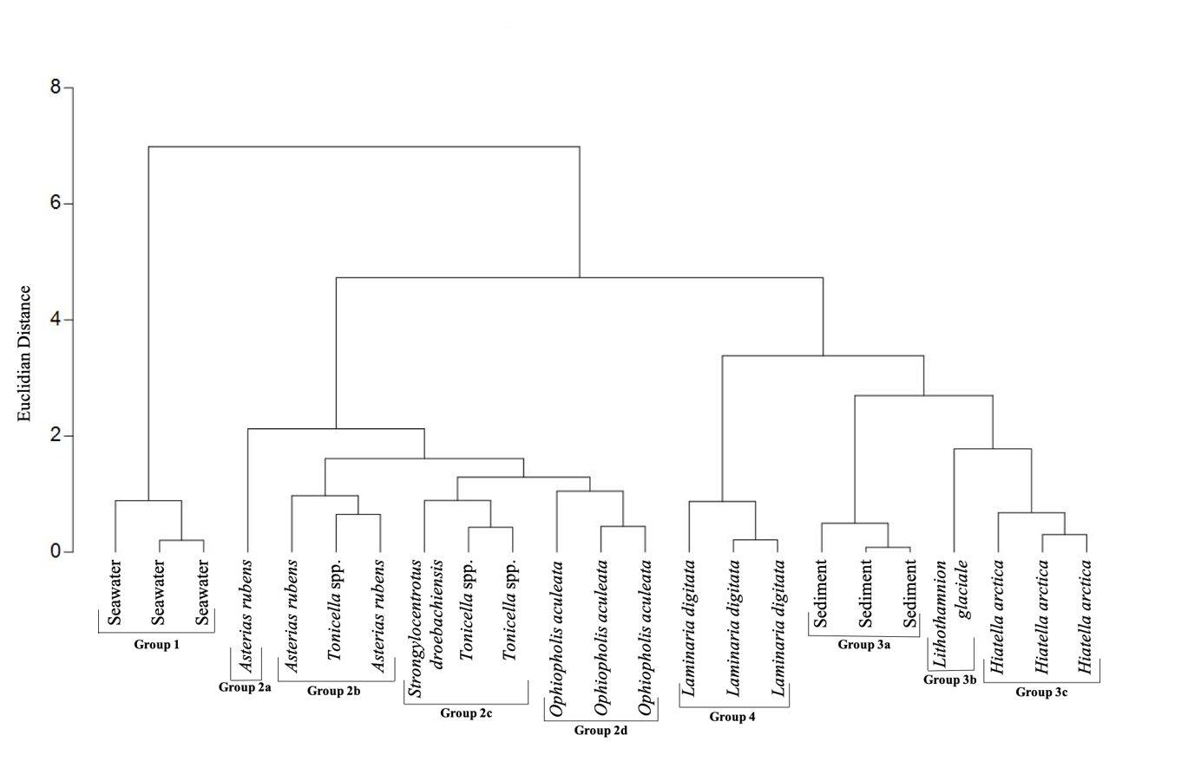
Figure S.1. Agglomerative hierarchical clustering (based on Euclidian distance) of bulk stable carbon (δ¹³C) and nitrogen (δ¹⁵N) isotope ratios in the six animal species, two macroalgal species, and two environmental components (see Table 1 for species list) sampled in the South site (see Figure 1A). Nereis spp. was not included because of insufficient tissues for quantification in the N analysis.

