Appendix A
General physicochemical environment and timing of phytoplankton bloom at the study site
The timing of the phytoplankton bloom at the study sites was confirmed by casting a CTD (conductivity, temperature, and depth) instrument (SBE - 19 PLUS; Seabird) with PAR (QSP2300; Biospherical Instruments Inc.) and fluorescence sensors (FLRT; WETstar fluorometer), every few days from 1 to 29 March, 2017, and again from 23 to 26 April, 2017. Ice covered the sea surface from 30 March to 22 April, preventing CTD casts during this period. For each cast we lowered the instrument from the ocean surface down to the surface of the rhodolith bed at a speed of ~1 m s⁻¹. Data collected by the CTD across the water column (i.e. PAR, fluorescence, pressure (depth), temperature, and salinity) were plotted with Ocean Data View V4.0 (https://odv.awi.de/) and SigmaPlot V11.0 and used to characterize the general physicochemical environment at the study site. Fluorescence data within the first 3 m above the rhodolith bed (i.e. between 12 and 15 m deep) were used to monitor the progression, and confirm the occurrence of, the bloom. Below we present fluorescence (Figure A.1A), temperature (Figure A.1B), and salinity (Figure A.1C) data from the sea surface down to the rhodolith bed from each of the three progressions. Only fluorescence data within 3 m above the bed were used in determining the timing of the bloom. This layer of water was deemed sufficiently narrow to capture benthic-pelagic trophic interactions relevant to the present study.
Inspection of the fluorescence data from March and April, 2017 indicated that the spring phytoplankton bloom began in the last few days of March and was still ongoing on 23 and 26 April, 2017 (Figure A.1A). Fluorescence above 12 m was more variable than below, with benthic levels gradually increasing throughout March and stabilizing in late April. Phytoplankton concentration on 23 April (when we sampled the rhodolith community and collected rhodoliths for food web analyses) was three to four times that on 8 March. Sea temperature varied more within the first 12 m than below, although the largest difference between coldest (14 March, 2017) and warmest (26 April, 2017) water across the entire water column did not exceed ~1.3°C (Figure A.1B). Salinity varied by less than ~0.4 PSU across the entire water column from 1 to 20 March, 2017, but exhibited marked changes, up to 2 PSU, within the first 5 m in the week that preceded the formation, and day that followed the retreat, of surface ice (Figure A.1C). Salinity below 12 m remained comparatively much more stable, with no obvious influence of sea ice and a faster return to pre-ice salinities.

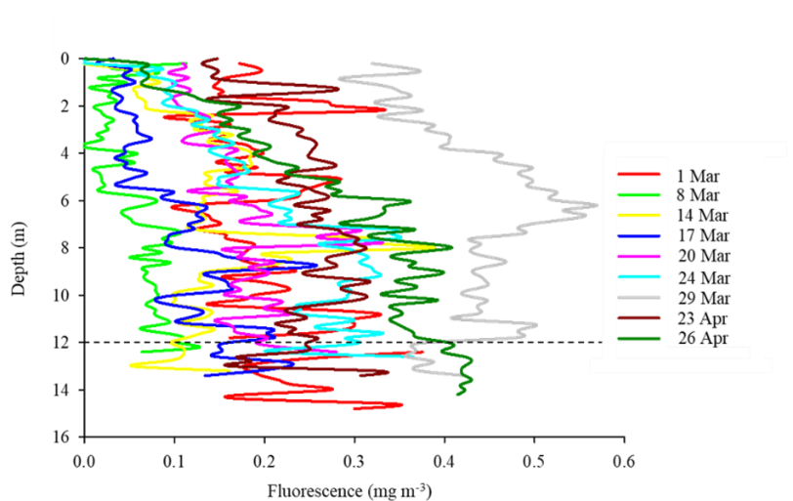
B
A
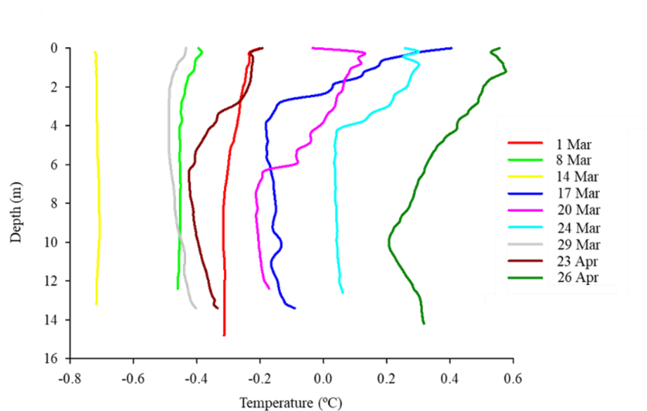
C
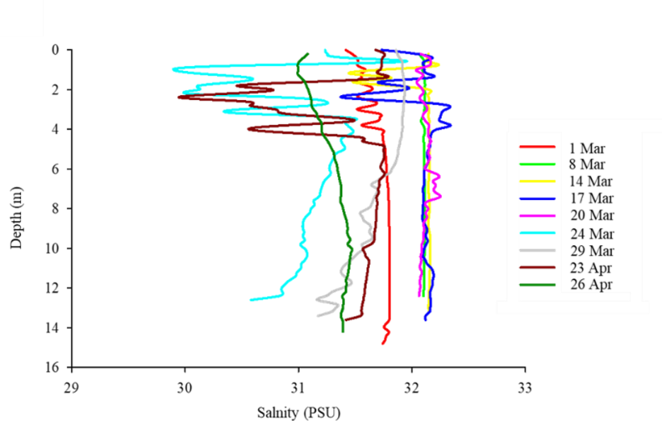
Figure A.1. (A) Fluorescence between the sea surface and rhodolith bed at 15 m depth at the South site through March 2017 and end of April 2017. The horizontal dashed line indicates the depth (12 m) below which fluorescence was considered in determining the timing of the phytoplankton bloom.(B) Temperature between the sea surface and rhodolith bed at 15 m depth at the South site through March 2017 and end of April 2017. (C) Salinity between the sea surface and rhodolith bed at 15 m depth at the South site through March 2017 and end of April 2017.

